Florence L. (Bienz) Moser
August 14, 1927 – September 29, 2026

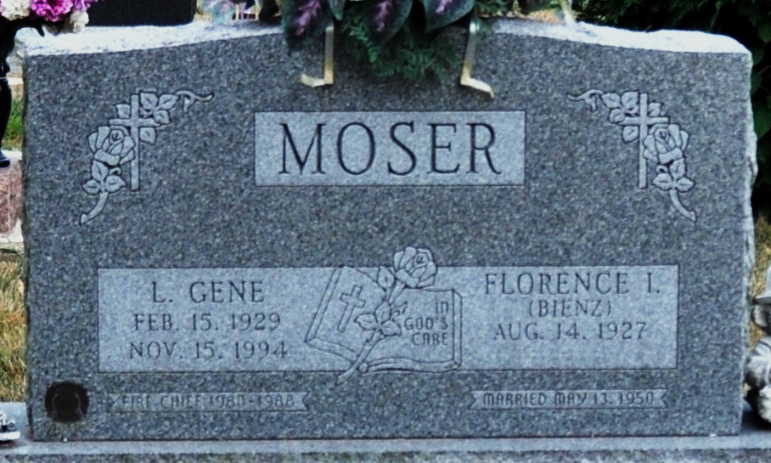
Photo by Deb Curry

Florence I. Moser, 99, of Decatur, Indiana passed away late Tuesday, September 29, 2026, at her daughter’s residence in Decatur. She was born on August 14, 1927 in Decatur, Indiana to Erwin C. and Emilie (Bulmahn) Bienz. Florence was united in marriage to L. Gene Moser at Immanuel Lutheran Church, Decatur, on May 13, 1950, and he preceded her in death on November 15, 1994.
She was a member of Zion Lutheran Church, Decatur, where she served the Lord on the Emmaus Guild, the Quilting Group, and the Altar Guild.
Florence was a graduate of Monmouth High School. She assisted her husband as a bookkeeper at 8th and Monroe Mobil Service Station. She was employed at Bellmont High School as a cook in the cafeteria for over 23 years until her retirement at the age of 74.
She enjoyed her flower and vegetable gardens, and was canning the fruits of that garden until last year. She loved crocheting, knitting and sewing. She was an excellent cook and loved sharing her food with family and friends. She especially looked forward to her family reunions where she could reestablish her connections, both with food and conversation. She was granted a great faith in her Lord Jesus Christ, and a desire to share it with her family. Her life was a testament to resilience, compassion, and unwavering faith.
She is survived by her daughter, Janet (Jack Esch) Moser of Los Angeles, California; son, Gary (Ryumi) Moser of Fort Wayne, Indiana; daughter, Sandra (Dick) Steury of Decatur, Indiana; son, Doug Moser of Huntertown, Indiana; brother, Leland (Phyllis) Bienz of Fort Wayne, Indiana; brother, Elgene (Pam) Bienz of Decatur, Indiana; daughter-in-law, Connie Moser of Decatur, Indiana; 13grandchildren, Jimi (Sheila) Moser, Travis (Amy) Moser, Ethan (McKenna) Moser, Timothy Moser, Sasha (Josh) Werst, Zach (Chantel) Moser, Matthew (Janay) Moser, Cory (Zack) Moser, Jamie (Jim) Skewis, Michelle (Adam) McCoy, Samantha (Kyle) Girod, Morghan (John) James, Madelyn (Kurt) Boggs; and 20 great-grandchildren.
Florence was preceded in death by two sons, Lynn Moser on January 26, 2017 and Duane Moser on November 28, 2024; two great-grandchildren, Peyton and Aidan McCoy; one great-great-granddaughter, Paisley Brown; three brothers and their spouses, Gilbert (Eunice) Bienz, Kenneth (Elvira) Bienz, and Frederick “Fritz” (Ruth) Bienz.
A funeral service will be held at 10:30 a.m. on Monday, October 5, 2026 at Zion Lutheran Church in Decatur with Pastor Zachary Oedewaldt officiating. Burial will follow at Decatur Cemetery. Family and friends will be received from 12 noon to 3:00 p.m. on Sunday, October 4, 2026, at Zwick & Jahn Funeral Home in Decatur and one hour prior to services at the church on Monday.
Memorials in Florence’s name can be given to Zion Lutheran Church in Decatur or ACCF Angel Fund – Dementia.

Zwick and Jahn Funeral Home, Adams County, Indiana
September 30, 2026

