John W. Morgan
June 29, 1941 – May 9, 2026

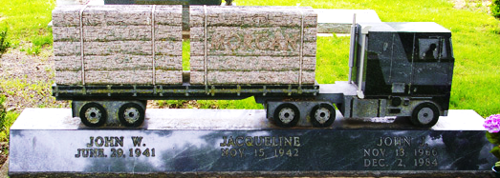
Photo by Corgilover

John W. Morgan, 84, of New Haven, IN, peacefully passed away on Saturday, May 9, 2026, at his residence. John was born on June 29, 1941, in Fort Wayne, IN, to the late Lloyd and Helen (Powell) Morgan. On June 19, 2000, he married Margo Shook.
He loved to spend time golfing, woodworking, and watching old western movies. John was an avid Fort Wayne Komets fan, and was a season ticket holder for over 40 years. He also served his country in the US Navy.
John is survived by his wife of 25 years, Margo Morgan of New Haven, IN; 3 daughters, Jill Bollenbacher of New Haven, IN, Jodi (Shane) Mills of Acworth, GA, and J.J. (fiancé Craig DeLucio) Treat of Greenwood, IN; a stepdaughter, Jenn (Tim) Pliett of New Haven, IN; his sister, Elaine Bosler of Angola, IN; 6 grandchildren and 2 great-grandchildren.
He is preceded in death by his son, John J. Morgan, and his sister, Marilyn Johnston. A Memorial Visitation will be from 3:00 – 7:00 p.m. on Friday, May 29, 2026, at Haggard-Hirschy & Zelt Funeral Home.
Military Graveside Rites will be rendered by the American Legion Adams Post 43 Color Guard, at 10:30 a.m. on Saturday, May 30, 2026, in the Decatur Cemetery. Preferred memorials are to Humane Fort Wayne or St. Jude’s. Haggard, Sefton & Hirschy Funeral Home in charge of arrangements.
Fort Wayne Newspapers, Allen County, Indiana
May 20, 2026

