Rex M. Moore
January 13, 1942 – December 6, 2024

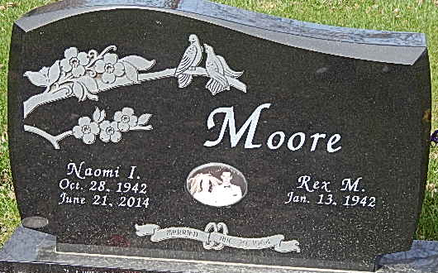
Photo by Alicia Kneuss

Rex M. Moore, of Decatur, Indiana entered into the arms of Jesus, Friday, December 6, 2024 at Lutheran hospital surrounded by the love of his children, grandchildren and great grandchildren. He was born on January 13, 1942 at his home in Harlan, Indiana to the late Paul Martin Moore and Violet Maxine (Smith) Moore. On August 29, 1964 Rex married the love of his life, Naomi Wallace, who preceded him in death on June 21, 2014. Rex then married Gayla Reinhart on January 16, 2016 in Monroe, Indiana.
Rex was a member of Boundless Church (formerly Common Ground), the Republican Party, Kiwanis and the NRA.
Our dad was driven by a strong work ethic that allowed him many different business ventures. He owned and operated Culligan Water Softeners in Decatur for two years, worked for Community Care Centers as an accountant/bookkeeper, was an accountant for Rawhide Boys Ranch in New London Wisconsin, a tax preparer for individuals and corporations for over 60 years. He and our mom owned and operated Kelly Dry Cleaners in Decatur, Indiana. He was formerly in banking for twenty years working at Decatur Bank & Trust and First Bank of Berne as a loan officer. He had a passion for politics and wanted to make a difference in his community, which led to his service as the Adams County Treasurer for two terms, County Commissioner for two terms and was then elected to two terms on the Adams County Council. Due to his health condition, it was with a heavy heart, that he decided it was best to resign from his position the summer of 2024.
In his spare time, dad took great joy in traveling, road trips, family vacations, that always included scenic detours, that promised to get us to our destination faster, but often was longer and once, even landed our family in a cow pasture!! Family vacations were known for lots of excitement and adventure, which was sure to tickle the ear of those who listened. Dad was passionate about working outside in the gardens, on his pond, tending to his many animals, tinkering around his property and in his barn where he enjoyed woodworking. He was an avid listener of Fox News and could easily get drawn into reading western books and watching western movies, as he always wished he could have been a cowboy! Dad loved listening to Southern Gospel music and even had a knack for writing some of his own lyrics to music.
Above all else he was a faithful follower of Jesus Christ and led his family by example. He knew the importance of family and keeping us grounded in the Word. Because of this, his time spent with our family was very special and important to him. He wanted nothing more than to spend eternity with his children, grandchildren and great grandchildren. He had hoped more than anything that he could have been alive for the rapture, but the joy of his homecoming celebration in Heaven will never be captured by words! One day we will all be together again.
He is survived by his wife, Gayla Reinhart of Decatur, Indiana; daughter, Mary Anne (Scott) Taylor of Leo, Indiana; daughter, Molly Farthing of Decatur, Indiana; son, Matthew (Jamie) Moore of Monroe, Indiana; daughter, Mindy (Eric) Tryon of Fishers, Indiana; brother Don (Susan) Moore of Beverly Hills, Florida; He was loved and adored by his 13 grandchildren; Jordan, Cameron, Landon, Quinton, Amber, Logan, Mariah, Jessah, Malakai, Elijah, Ella, Evie and Macguire; 9 great grandchildren; Ezekiel, Levi, Naomi, Paisley, Harper, Brantley, Colter, Max and Mayla (and one due in March). Step sons; Stephen and Jeremy, step granddaughter, Mera.
Along with his parents and his first wife, he was preceded in death by his two aunts; Betty Woods and Eleanor Stapleton; and two uncles, Paul Smith and Carl Smith.
A celebration of life will be held on what would have been our dad’s 83rd birthday, at 10:30 a.m. January 13, 2025 at Cornerstone Community Church in Decatur, Indiana with a committal service to follow at Decatur Cemetery. Friends and family will be received from 12-6 p.m. on Sunday, January 12, 2025 at Zwick and Jahn Funeral Home in Decatur, Indiana and one hour prior to the celebration of life on January 13, 2025 at Cornerstone Community Church.
Memorials can be given to Wounded Veterans of America.

Zwick & Jahn Funeral Homes, Adams County, Indiana
December 15, 2024

