Madeleine M. (Kelsey) Miller
January 13, 1936 – April 24, 2025

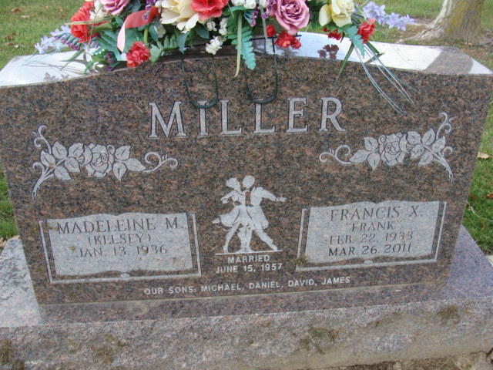
Photo by Alicia Kneuss

Madeleine M. Miller, 89, of Decatur, IN, passed away on Thursday morning, April 24, 2025, at her residence. She was born on January 13, 1936, in Fort Wayne, IN, the daughter of the late Gayle M. and Marcella E. (Klaren) Kelsey. On June 15, 1957, Madeleine married Francis X. “Frank” Miller and after 53 years, he preceded her in death on March 26, 2011.
She was a parishioner of St. Mary of the Assumption Catholic Church and was a 1954 graduate of Central Catholic High School. She worked for Fort Wayne Newspapers for 21 years. Madeleine enjoyed dancing, especially with her late husband and they also enjoyed the music of The Bulldogs. She loved her in-ground swimming pool, camping, and the many summers on Golden Lake and Big Long Lake. Above all she loved helping raise her grandchildren and being a part of their lives.
She is survived by her 3 sons, Mike (Alicia) Miller of Decatur, IN, Dan (Shelly) Miller of Fort Wayne, IN, and Dave (Kathy) Miller of Monroe, IN; 11 grandchildren, Ryan (Tammy) Miller, Sarah (Jeff Teeple) Miller, Rachel Miller, Melinda Miller, Casey (Ted) Zeunik, Mark Miller, Daniele (Ben) Thomas, Michael (Lauren) Miller, Quentin Miller, Addison Miller & Brooklynn Miller; 5 great grandchildren, Juliana Banuelos, Jack Miller, Logan Zeunik, Calvin Zeunik & Xander Miller.
Madeleine was preceded in death by her son, James E. Miller and her brother, Eugene P. Kelsey.
Visitation will be from 4:00 – 7:00 p.m. on Thursday, May 1, 2025, at Haggard-Hirschy & Zelt Funeral Home, with a reciting of the Holy Rosary at 3:30 p.m. A Mass of Christian Burial will be offered at 10:00 a.m. on Friday, May 2, 2025, in St. Mary of the Assumption Catholic Church, with visitation from 9:00 – 10:00 a.m. in the St. Mary’s Parish Hall before the Mass. Father David Ruppert will be presiding and burial will follow in the Decatur Cemetery.
Memorials may be made to St. Joseph Catholic School.

Haggard-Hirschy & Zelt Funeral Home, Adams County, Indiana
May 2, 2025

