Karen E. (Whittenbarger) Miller
February 25, 1943 — July 5, 2026

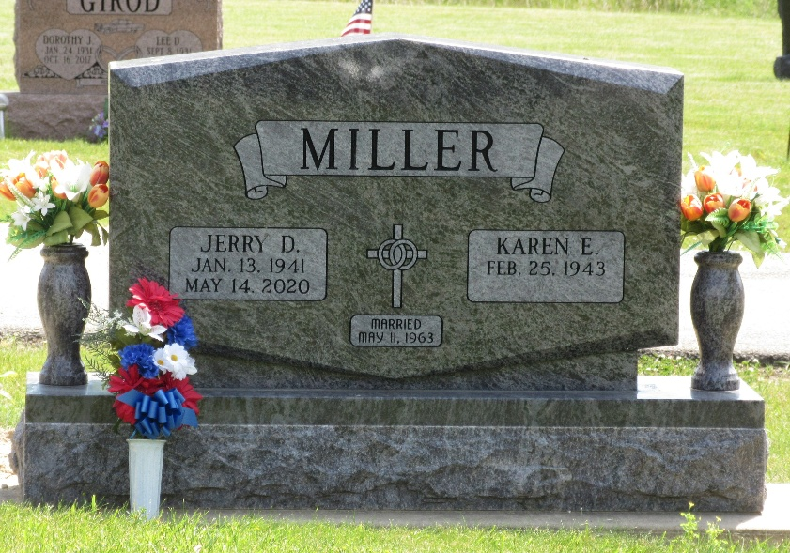
Photo by PLS

Karen E. Miller, 83, of Decatur, Indiana passed away Sunday evening, July 5, 2026, at Adams Woodcrest. She was born on February 25, 1943 in Decatur, Indiana to George and Florence (Lovellette) Whittenbarger. On May 11, 1963 Karen was united in marriage to Jerry D. Miller at Decatur Assembly of God in Decatur, Indiana, and he preceded her in death on May 14, 2020.
She was a former member of the Countryside Church of the Nazarene and now is currently a member of Mount Zion United Brethren Church in Bobo. She was also a member of the American Legion Post #43 Auxiliary in Decatur and Anytime Fitness, Forever Fit Group. She worked in housekeeping at Adams Memorial Hospital for 20 years. Karen was also a faithful homemaker, raising her family as Jerry’s military career moved the family to many different locations.
She loved working with flowers and greatly loved and enjoyed spending time with her grandchildren and great grandchildren. On Wednesday mornings, you would find Karen at her weekly Bible study where she was a devoted member and follower of Christ.
She is survived by her daughter, Teresa (Greg) Voglewede of Decatur, Indiana; son, Tony (Teresa) Miller of Fort Wayne, Indiana; daughter, Angie (Mitch) Baumann of Decatur, Indiana; twin sister, Sharon Snyder of Decatur, Indiana; sister, Bonnie Knittle of Decatur, Indiana; sister, Janice Kline of Auburn, Indiana; sister-in-law, Norma Whittenbarger of Decatur, Indiana; nine grandchildren, Jason (Chelsey) Voglewede, Aaron (Riley) Voglewede, Brandon (Demi) Voglewede, Miranda (Nick) Huffine, Cameron Voglewede, Amanda (Anthony Riecke) Miller, Paige (Sam) Kipp, Madilyn (Cole) Cunningham, and Jacob (fiancé, Ashlynn Abell) Baumann; 17 great-grandchildren, Chandler Voglewede, Clare Voglewede, Cyler Voglewede, Celah Voglewede, Tate Wilson, Brooklynn Wilson, Keaton Voglewede, Hudson Voglewede, Palmer Voglewede, Layton Huffine, Kristine Huffine, Janey Huffine, Lennon Voglewede, Addison Wagner, Rylann Riecke, Hennleigh Riecke, Kennedy Cunningham, and baby Kipp; and baby Voglewede on the way.
In addition to her husband, Jerry, and her parents, Karen was preceded in death by two sisters, Wanda Case and Phyllis Whittenbarger; brother, Larry Whittenbarger; and brother-in-laws, Gerald Knittle, Max Case, and Gordie Snyder.
A funeral service will be held on Thursday, July 9, 2026, at 10:30 a.m. at Zwick & Jahn Funeral Home in Decatur with Pastor Ernie Suman officiating. Burial will follow at Decatur Cemetery. Family and friends will be received from 2 to 4 p.m. and 5 to 8 p.m. on Wednesday, July 8, 2026 at Zwick & Jahn Funeral Home in Decatur and one hour prior to the service on Thursday at the funeral home.
Preferred memorials are to Mount Zion United Brethren Church, Bobo; Stillwater Hospice; or American Legion Post #43.

Zwick & Jahn Funeral Homes, Adams County, Indiana
July 6, 2026

