Infant Miller
March 25, 1901 – March 26, 1901

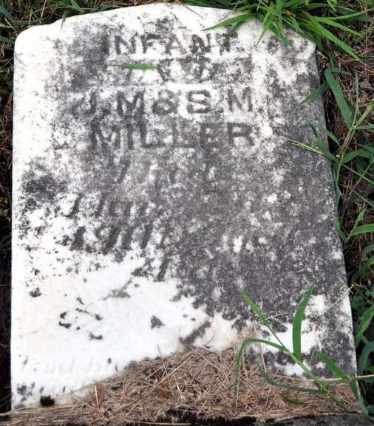
Photo by Deb Curry

Mrs. J. M. Miller is very ill and her friends are alarmed over her condition. A baby boy, but a few days old, died Tuesday.
Decatur Democrat; Adams County, Indiana
A weekly newspaper
Thursday, March 28, 1901

**
Indiana, U.S., Death Certificates, 1899-2011
Name: Infant Miller
Gender: Male; Race: White; Age: 1 day
Marital status: Single
Birth Date: abt 1901; Birth Place: Decaton Ind
Death Date: 26 Mar 1901; Death Place: Decatur, Adams, Indiana, USA
Father: J M Miller
Mother: Sadie M. Archer?
Informant: J. M. Miller; Decatur, Indiana
Burial: March 27, 1901; Decatur Cemetery

