Larry D. Meyer
December 24, 1947 – March 19, 2024

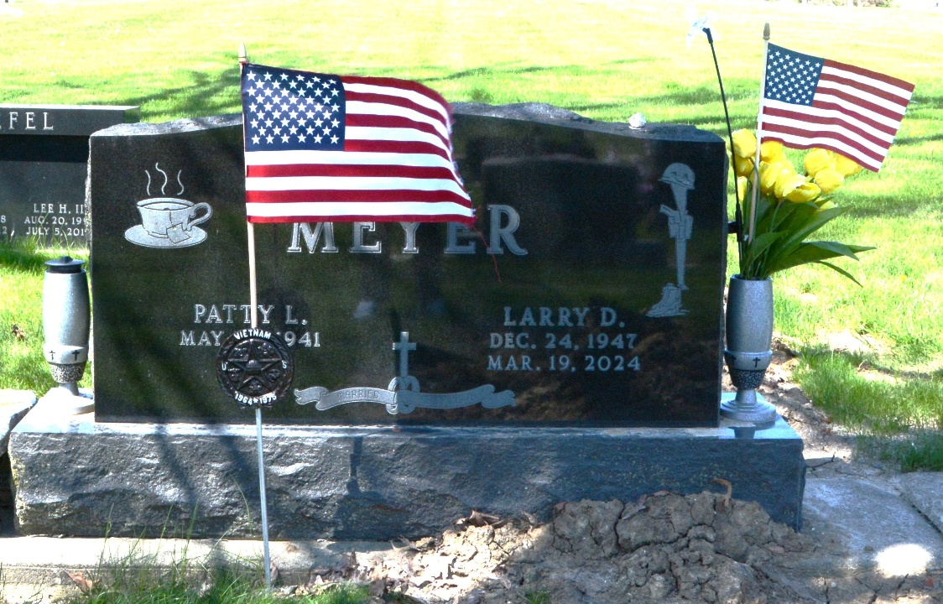
Photo by Deb Curry
Larry D. Meyer, 76, of Decatur, Indiana passed away on Tuesday, March 19, 2024, at his residence. He was born on December 24, 1947, in Decatur, Indiana to the late John E. Meyer and the late Nola Faye (Mauller) Meyer. Larry was united in marriage to Patty (Frank) Bailey on June 24, 1978 at Zion United Church of Christ in Decatur.
He served his country in the United States Army from 1967 to 1969 during the Vietnam conflict in the Tet Offensive and Kahm Duc. Larry was a triple Purple Heart recipient. Larry was on the first Purple Heart Honor Flight.
Larry was a member of the American Legion Post #43 of Decatur and the Moose Lodge #1311 of Decatur.
He was a 1966 graduate from Decatur Catholic High School and following high school he received a journeyman’s card as journeyman electrician from IBEW #305. He was an electrician for over 50 years, working 26 years at IBEW #305 and 19 years at ITT.
Larry enjoyed collecting Vietnam memorabilia and watching old cowboy movies.
Survivors include his wife, Patty Meyer of Decatur, Indiana; two sons, Shaun (Sarah) Meyer and Nathan (Tammy) Meyer both of Decatur, Indiana; granddaughter, Jessica (Adam) Keller Sinclair of Decatur, Indiana; sister, Linda (Greg) Clifton of Decatur, Indiana; grandchildren, Mercedes, Monique, Addie & Finn; great-grandchildren, Noah, Reid, Malachi, & Rainna; great-great grandchild, Ryleigh; and several nieces & nephews.
In addition to his parents, he was preceded in death by siblings, John E. Meyer Jr., Dan Meyer, Gary Meyer, Janet Tharp and son, Greg Bailey.
A funeral service will be held at 10:30 a.m. on Saturday, March 23, 2024, at Decatur Church of God with Pastor Brent Doster. Burial will follow in the Decatur Cemetery and Military Honors will be conducted by the American Legion Post #43. Family and friends will be received from 2 to 7 p.m. Friday, March 22, 2024, at Zwick & Jahn Funeral Home in Decatur and one hour prior to the service at the church on Saturday.
Preferred memorial can be given to the Honor Flight Northeast Indiana, Stillwater Hospice or Tunnels to Towers.

Zwick & Jahn Funeral Home, Adams County, Indiana
March 19, 2024

