Gary Lee Meyer
December 24, 1947 – January 11, 2024

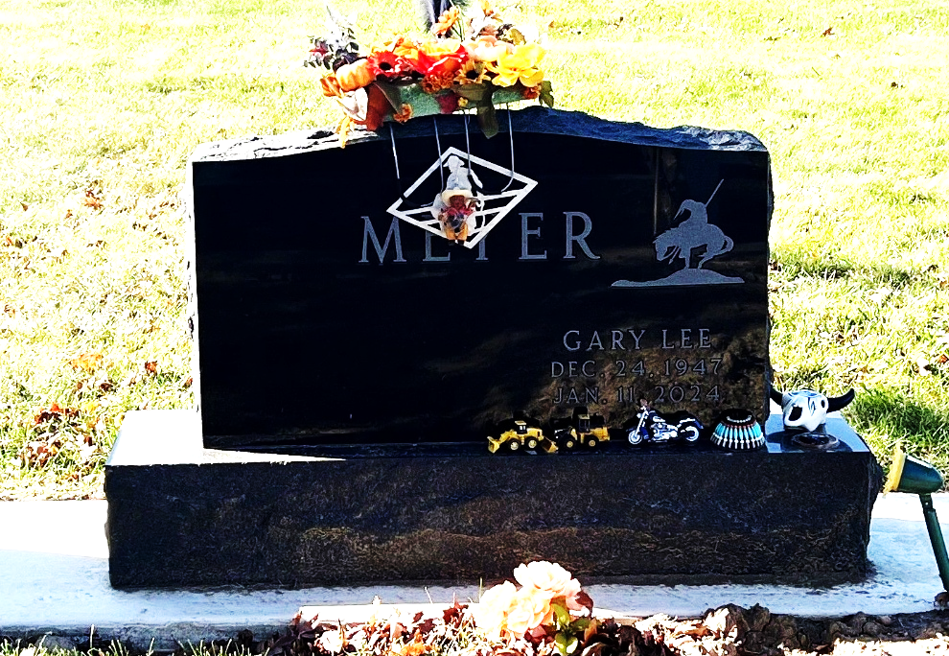
Photo by Deb Curry

Gary Lee Meyer, 76, of Decatur, Indiana passed away on Thursday morning, January 11, 2024, at Lutheran Hospital in Fort Wayne, Indiana. He was born on December 24, 1947, in Decatur, Indiana to the late John E. Meyer and Nola Faye (Mauller) Meyer
Gary was a member of Decatur Eagles #2653, V.F.W. #6236, Moose Lodge #1311, American Legion Post #43. He was a Heavy Equipment Operator for the Local Union #103. Gary loved his children, grandchildren, great-grandchildren and spending time with his family.
He is survived by his son, Nick (Genevive) Meyer of Hoagland, Indiana; sister, Linda (Greg) Clifton of Decatur, Indiana; twin brother, Larry (Patty) Meyer Decatur, Indiana; lifetime companion, Jeanne Harvey of Decatur, Indiana; nine grandchildren and five great-grandchildren.
In addition to his parents, Gary was preceded in death by a sister, Janet Tharp; two brothers, John and Danny Meyer.
Private family services and burial will take place at Decatur Cemetery. Preferred memorials are to ACCF – Cancer Fund.

Zwick and Jahn Funeral Homes, Adams County, Indiana
January 15, 2024

