Nimrod McCullough
January 15, 1868 – January 1, 1923

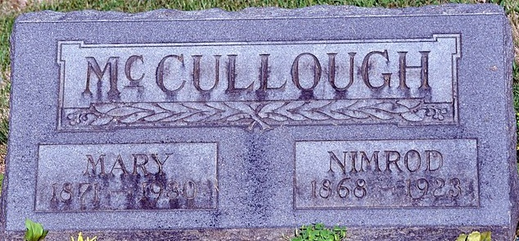
Photo by Deb Curry

LOCKJAW TAKES LIFE OF FARMER
Nimrod McCullough, Prominent St. Mary’s Township Farmer, Died Monday
Nimrod McCullough, age 54 years, prominent farmer of St. Mary’s Township, died at his home yesterday, from lockjaw, which resulted from an ulcerated tooth. Mr. McCullough was well known in the community of his residence and throughout the county.
Nimrod McCullough was born in Hancock County, Ohio, January 15, 1868, and would have been 55 years old this month. He was the son of Davis and Anna Murphy McCullough. The early years of his life were spent on a farm in Adams County, and his advantages were those of the district schools. He remained at home until he reached the age twenty-one years. On December 24, 1891, McCullough was married to Mary G. Smith, a daughter of William and Mary C. Smith, natives of Adams County. The McCullough family has been active in the Methodist Church at Pleasant Mills for many years.
Five children survive besides the wife. The children are William of Marion; Charles, of Auburn; Mrs. Amy Logan of Bryan, Ohio; and Benjamin and Nimrod, at home. Four sisters and one brother also survive. They are Mrs. Louis Ricker, Willshire, Ohio; Mrs. Louis Hammond, Decatur; Mrs. Frank Winans, Decatur; Mrs. William Herst, Decatur; and James McCullough, of Decatur Rural Route.
Funeral services will be held from the Methodist Church in Pleasant Mills at 10 o’clock Wednesday morning and burial will be held in the Maplewood Cemetery at Decatur. The Rev. Naupin will have charge of the funeral service.
Decatur Daily Democrat, Adams County, Indiana
Tuesday, Jan. 2, 1923

**
Indiana, U.S., Death Certificates, 1899-2011
Name: Nimrod McCoullough
Gender: Male
Race: White
Age: 54
Marital status: Married
Birth Date: 15 Jan 1868
Birth Place: Ohio
Death Date: 1 Jan 1923
Death Place: St Marys, Adams, Indiana, USA
Father: Davis McCoullough
Mother: Anna Murphy
Spouse: Mary G Smith
Informant: Mary G. McCoullough; Pleasant Mills, Indiana
Burial: January 3, 1923; Decatur, Indiana
**
Nimrod McCullough of St. Mary's Township is the type of sturdy and intelligent farmer citizen who now more than at any other time in history has a recognized value and indispensability in the scheme of things. Mr. McCullough has spent many long years of earnest work, has utilized the benefits of experience and directed his tasks by intelligence as well as hard work, and is now one of the men in comfortable circumstances in Adams County. His farm is a mile southeast of Pleasant Mills.
Mr. McCullough was born in Hancock County, Ohio, January 15, 1868, a son of Davis and Anna (Murphy) McCullough. The father was born in Knox County, Ohio, in 1834. The grandfather, William McCullough, was a Pennsylvanian, married in that state, and on moving to Knox County settled on a farm where he spent the rest of his years. His children were James, Benjamin, Samuel, Davis, Thomas and Elizabeth. Davis McCullough grew up on the old farm in Knox County, Ohio, was educated in the common schools, and after his marriage to Anna Murphy lived in Hancock County until 1869, when the family moved to Adams County, Indiana, locating near Decatur.
In 1876 they established a new home near Pleasant Mills and in that locality Davis McCullough spent his last years. His widow is still living. There were ten children, eight of whom are living at present: Ella, wife of Frank Winans of Decatur; Catherine, wife of Lewis Hammond; Naomi, wife of Lewis Reiker; Nimrod; Jeanette, wife of Lee Conklin of Greentown, Indiana; Anna, wife of Gideon Burnette; Mina, wife of William Herst; and James, who lives near Monroe, Indiana. The early years of Nimrod McCullough were spent on a farm in Adams County, and his advantages were those of the district schools. He remained at home to the age of twenty-one.
On December 24, 1891, he married Mary G. Smith, daughter of William and Mary C. (Fordice) Smith, both natives of Adams County, Indiana. Her father grew up in this county and in the spring of 1864 enlisted in Company G of the Forty-seventh Indiana Infantry and saw active service as a soldier until the end of the war. He was a prominent Republican and for six years served as trustee of St. Mary's Township. Mrs. MeCullough was one of three children, the other two dying in infancy. She grew up on the farm where she now lives and was educated both in the schools at Pleasant Mills and in the Methodist College at Fort Wayne. Mrs. McCullough has a notable record as a teacher and hundreds of men and women acknowledge their gratitude to her for the worthy influences that surrounded their early lives. She began teaching in 1888 and altogether has taught twenty-four terms. She still has charge of the home school in District No. 6, St. Mary's Township. Mrs. McCullough is the mother of five children, and has given much of her time to their rearing and training.
William, the oldest, is a graduate of the common schools and married Hazel Campbell; Charles also graduated from the common schools and the Decatur High School and married Thelma Patterson. Amy, when she graduated from the common schools at the age of fourteen had the highest grade of any pupil in the county. Benjamin and Nimrod, Jr., are still students in the common schools. The families are active members of the Methodist Episcopal Church at Pleasant Mills, and Mr. McCullough votes as a Republican. The country home of the McCullough’s comprises a farm of sixty-five acres, well cultivated, in a high state of improvement, and with all the comforts that go with rural life in these modern times.

History of Adams and Wells Counties, Indiana: Volume 2; John Wilson Tyndall, Orlo Ervin Lesh

