Emma Amelia (Wand) McBarnes
December 7, 1858 – May 26, 1923

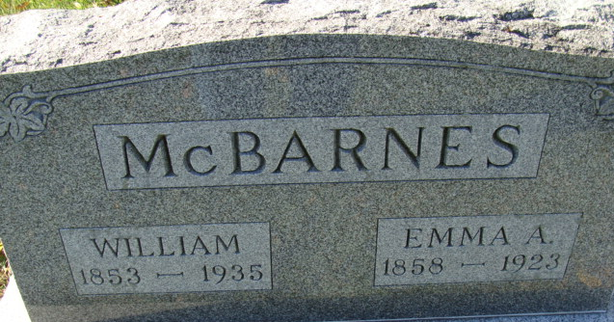
Photo by Alicia Kneuss

MRS. MCBARNES DIED SATURDAY
Wife Of William McBarnes Died Following Illness of Years Duration
Mrs. Emma Amelia McBarnes, age 63 years, for more than fifty years a resident of Decatur, died at her home, 413 McBarnes Street, at 9:40 o’clock Saturday night, following an illness of kidney and liver trouble for the last year. Mrs. McBarnes was bedfast only one week, however.
Mrs. McBarnes, the daughter of James and Jane Wand, was born in Chicago, December 7, 1859. She came to Decatur when six years old and spent the remainder of her life here. On June 29, 1876, she was united in marriage to William McBarnes, who survives. Their four children are Mrs. Verna M. Avery, of Decatur; Mrs. George Kern, of Fort Wayne, and Mrs. Frank Butler, of Decatur. One son, John is deceased.
Funeral services will be held from the Evangelical Church at 2:30 o’clock Tuesday afternoon, the Rev. R. W. Loose, pastor of that church, officiating. Mrs. McBarnes was a member of the Evangelical Church. Interment will be held in the Decatur Cemetery. Short services will be held at the house at 2 p.m.
Decatur Daily Democrat, Adams County, Indiana
Monday, May 28, 1923

