James Neal Markley
September 13, 1931 – June 27, 2024

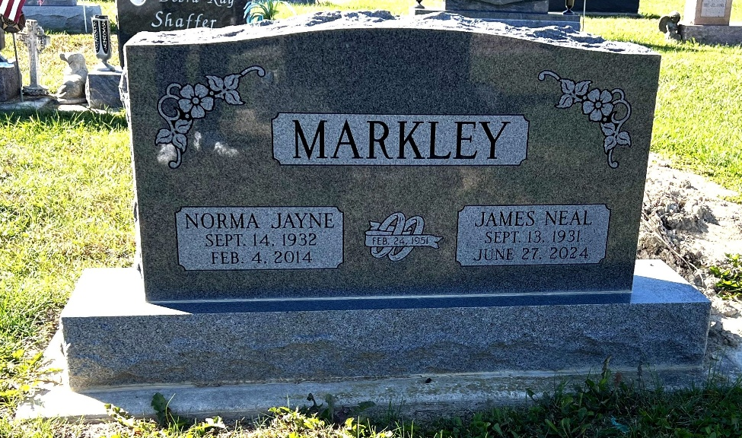
Photo by Deb Curry

James N. Markley 92, of Decatur, Indiana passed away Thursday morning, June 27, 2024, at Betz Nursing Home in Auburn, Indiana. He was born on September 13, 1931, in Poneto, Indiana to the late Lewis Markley and Mildred Inez (Schott) Markley. On February 24, 1951, Jim married Norma Jayne Brown at the First United Methodist Church in Decatur and she preceded him in death on February 4, 2014.
Jim was a 1949 graduate of Bluffton High School. He attended Milo Bennett Type School to learn type setting. He was employed at A1 Type Service in Fort Wayne from 1962 to 1967 and then was the owner and operator of Typo Graphic Compositors in Fort Wayne from 1967 to 1990. He also worked for nine years as a type setter at the Decatur Daily Democrat and as a salesman for Sheets Furniture in Decatur. Jim enjoyed bowling, playing cards, traveling, and sports of all types.
He is survived by his daughter, Valerie Markley of New Haven, Indiana; daughter, Lynn (Wayne) Funk of Garrett, Indiana; eight grandchildren, Christopher, Kevin, Katherine, Craig, Rebecca, Andrea, Erica, and Peter; nine great-grandchildren; and one great-great-grandchild.
Jim was preceded in death by two sons, Steve & Scott Markley; two sisters, Phyllis Poling and Ann Walton; and three brothers, Kenneth Markley, Roderick Markley, and Richard Markley.
Private family services will be held and burial will take place Decatur Cemetery. Preferred memorials can be given to the ACCF – Cancer Fund.

Zwick & Jahn Funeral Homes, Adams County, Indiana
July 4, 2024

