Winonna M. (Miller) Light
November 19, 1934 – February 10, 2024

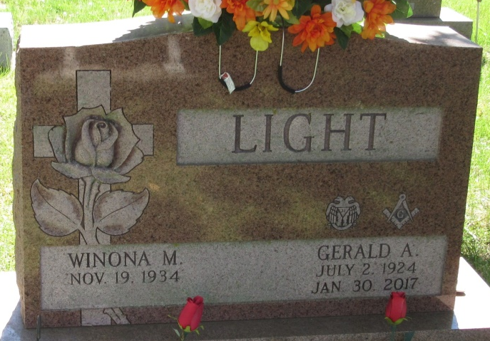
Photo by PLS

Winona M. “Winnie” Light, 89, of Decatur, IN, passed away on Saturday, February 10, 2024 at Adams Woodcrest. Winnie was born on November 19, 1934 in Decatur, to the late Curtis L. and Phoebe E. (Hart) Miller. On November 19, 1955, Winnie married Gerald A. “Jerry” Light; he preceded her in death on January 30, 2017.
Winnie was a member of St. Mark’s Church Decatur and the Order of the Eastern Star. She was a 1952 graduate of Decatur High School and a 1980 graduate of IPFW Purdue with a degree in Nursing. In her lifetime as a nurse, she had worked for Cooper Rest Home, Lakeside Nursing Home, Adams County Memorial Hospital and Dr. Lee and Dr. Gresla’s Office. Winnie retired from nursing in 2011.
Winnie also was an avid golfer and bowler; and her grandchildren were her life!
She is survived by her 6 children, Sandra (Pete) Adams, Eric (Carolyn) Light, Donna (Dave) Mills, Greg (DeeDee Jauregui) Light, Debra Schevenius and Brenda (Dean Cornett) Light all of Decatur; 16 grandchildren, Jamie (Jeremy) Roush, Tonya (Joel) Massoth, Christin (Jeremy) Casserly, Angela Light, Ashley (Nick Seip) Light, Nick (Tasha) Braun, Emily (Armando) Larranaga, Jared Light, Michelle Schevenius, Nicole (Spenser) Claxton, Eric (Keyara) Schevenius, Sheri (Jason) Ellsworth, Jeff (Liz) Adams, Mark (Melanie) Mills, Jeff (Carla) Mills, Josh (Lisa) Mills, and Patrick Schevenius; 34 great grandchildren and 3 great-great grandchildren.
Winnie was preceded in death by 3 brothers, Charles “Bill” Miller, Dick Miller, and Wendell Miller; 2 sisters, Deloris Burley, and Marcella Bryan.
Visitation will be on Thursday, February 15, 2024 from 3:00 – 7:00 p.m. at Haggard-Hirschy & Zelt Funeral Home. Funeral Service for Winnie will be held at 10:00 a.m. on Friday, February 16, 2024 at Haggard-Hirschy & Zelt Funeral Home with calling 1 hour prior from 9:00 – 10:00 a.m. Pastor John McCullough officiating. Burial will follow in Decatur Cemetery.
Preferred memorials are to A.C.C.F. Nursing Scholarship, St. Mark’s Church Decatur, or Union Chapel UMC.

Haggard & Sefton Funeral Home, Adams County, Indiana
February 11, 2024

