Earl Steven Liechty
January 16, 1940 – June 11, 2023

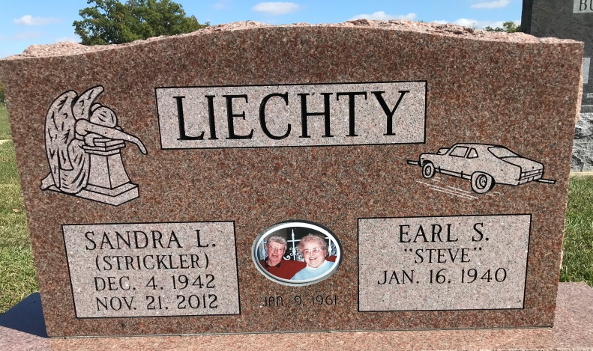
Photo by Alicia Kneuss

E. Steven “Steve” Liechty, 83, of Berne, passed away Sunday, June 11, 2023, at his residence. He was born in Adams County, Indiana on January 16, 1940, the son of Clifton and Dessie M. (McCune) Liechty. On January 9, 1961, Steve married Sandra L. Strickler, she preceded him in death on November 21, 2012.
He was a member of West Missionary Church and taught ‘the last class to Heaven’ and graduated! Steve was employed at the Berne Hi-way Hatchery, retiring after 40 years.
Steve is survived by his 3 sons, Scott J. (Marlene) Liechty of Midland, MI, Troy S. (Kristen) Liechty of Fort Wayne, IN, Rev. Brent C. (Loretta) Liechty of Orrstown, PA; a daughter, Teresa “Terri” Liechty of Berne, IN; a sister, Grace Moser of Berne, IN; a brother-in-law, Ron Kelley of Decatur, IN; a sister-in-law, Lyn Strickler of Decatur, IN; 7 grandchildren, Steven, Kristen, Lauren, Megan, Laurelei, Susanna and Gabriel Liechty.
He was preceded in death by his parents; his wife of 52 years, Sandra Liechty; a sister and brother-in-law, Julia (Robert) Beitler; a brother-in-law, Loren Moser; 2 grandchildren, Marissa and Katelyn Liechty.
Visitation will be 3:00 – 7:00 p.m. Thursday, June 15, 2023, at Haggard-Hirschy & Zelt Funeral Home. A Funeral Service will be held at 11:00 a.m. Friday, June 16, 2023, at West Missionary Church, Berne with calling 1 hour prior to the service from 10:00 – 11:00 a.m. Pastor Keith Rupp and Rev. Brent Liechty will be officiating and burial will follow in Decatur Cemetery.
Memorials may be made to Gideon’s International or Stillwater Hospice.
Haggard-Sefton & Hirschy Funeral Home, Adams County, Indiana
June 12, 2023

