Mary Naomi (Poling) Liby
December 21, 1895 – November 30, 1923

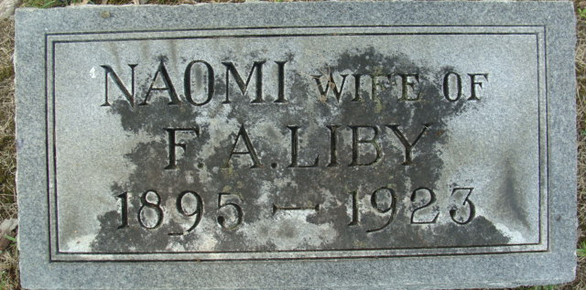
Photo by Alicia Kneuss

Mary Naomi Liby, daughter of C. B. and Ida Poling, was born in Washington Township, Adams County, December 21, 1895, and died at the Adams County Memorial Hospital November 30, 1923, aged 27 years, 11 months and 8 days.
She lived with her parents in Washington Township until their removal to Decatur two years ago, since which time she has resided in this city.
After completion of the grades in the rural school, she took up her studies in the Decatur High School from which she was graduated in 1915.
Being a member of the great chorus in the Honeywell Tabernacle meeting she came under conviction, was converted and united with the Washington M.E. Church. She became a very valuable worker in that church particularly as pianist and to work among children. On coming to Decatur during the pastorate of the Rev. Charles Tinkham, her membership was transferred to the First M. E. Church.
She was married Sept. 20, 1923, to Floyd Liby, who is prostrated with grief over the loss so very soon of the companion of his heart.
She is survived by her husband, her father and mother, her brother, Rolland and sister, Mrs. Merle Evans, of Etna, Ind., and a large circle of relatives and friends.
Mrs. Liby was highly esteemed by all who knew her and was held in deep affection by them all. Even many who did not enjoy a personal acquaintance greatly respected her, which speaks in the highest terms of her, for she was a young lady of many excellent qualities.
Decatur Daily Democrat, Adams County, Indiana
Tuesday, December 4, 1923

**
Mrs. Mary Naomi Liby, Young Wife, Died at Hospital This Morning
Mrs. Mary Naomi Liby, 27, wife of Floyd Liby, died at the Adams County Memorial Hospital at 8 o’clock this morning, following an illness of nine weeks of typhoid fever. Mrs. Liby was taken to the hospital for treatment a week ago today.
The deceased was born in Washington Township, Adams County, December 21, 1895. She was the second child of C. B. and Ida Poling. She was married to Floyd Liby on September 20 of this year. Their home was at the corner of Jefferson and Sixth Streets. Mrs. Liby was a member of the Methodist Church.
Besides the parents and sorrowing husband, one brother, Roland of Washington Township, and one sister, Mrs. Merle Evans, of Kimmell, Indiana, survive.
Funeral services will be held from the Methodist Church at 2 o’clock Sunday afternoon, the Rev. U. S.A. Bridge, the pastor, officiating. Short services will be held from the residence at 1:30 o’clock. Burial in the Maplewood Cemetery.

Decatur Daily Democrat, Adams County, Indiana
Friday, November 30, 1923

