Tammy I. (Wolfe) Lee
November 12, 1962 -

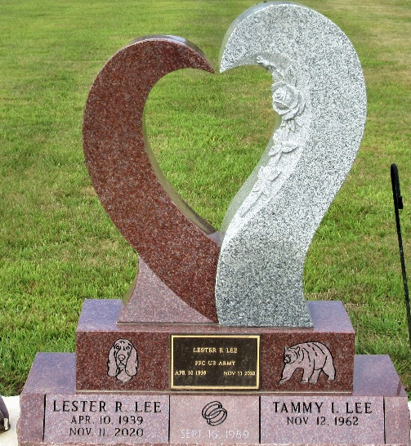
Photo by PLS

