Lester R. Lee
April 10, 1939 – November 11, 2020

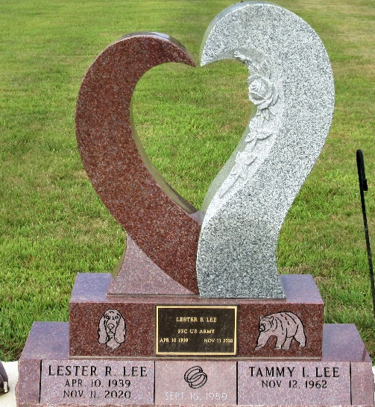
Photo by PLS

Lester R. Lee, 81, of Decatur, IN passed away on Wednesday, November 11, 2020 at Parkview Regional Medical Center. Lester was born on April 10, 1939 in Huntingdon, PA to the late Roger L. and Bernett D. (Renschler) Lee. On September 16, 1989, Lester married Tammy I. Wolfe.
Lester was a former member of the Calvary Temple. He was a lifetime member of the American Legion Post 43, where he was very active in the Color Guard and was Past Commander; a lifetime member of the V.F.W.; a lifetime member of the Amateur Hamm Radio; a member of the Eagles Lodge in Decatur and member of the Knight Templar’s. He played in the Fort Wayne Community Band and loved to lend a helping hand to anyone in need.
Lester served his country in the United States Army. When Hawaii became a state in 1959, he had the opportunity to represent Pennsylvania and fire the cannon during the ceremony. He also represented Indiana by playing everlasting TAPS across America at Bath, NY on May 21, 2005.
He is survived by his wife of 31 years, Tammy I. Lee of Decatur; 2 sons, Roger S. Lee and Guy L. “Tiny” (Heather) Lee both of Decatur; 7 grand-3
children, Guy’s son's, Magnuss, Delsyn and Kaigan, Caleb (Alisha), Rogers's kids Emily, Rebecca, and Alex David.
Funeral Services will be held at 1:30 p.m. on Saturday, November 21, 2020 at Haggard-Sefton-Hirschy & Zelt Funeral Home. Visitation will be from 11:00-1:00 p.m. prior to services. Burial will be in Decatur Cemetery with Military Graveside rites by American Legion Post 43 Color Guard.
Memorials may be given to ACCF Angel Kidney Fund.

Haggard & Sefton Funeral Home, Adams County, Indiana
November 12, 2020

