Charlotte (Kreischer) Ladd-Stevens
March 18, 1886 – July 3, 1969

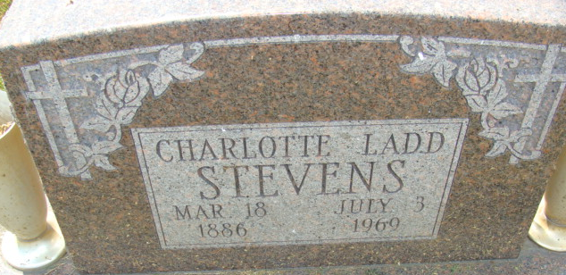
Photo by Alicia Kneuss

Decatur – Services for Mrs. Charlotte Ladd Stevens, 83, who died Thursday evening in Adams County Hospital, will be 2 pm Sunday in the Winteregg-Linn Funeral Home. Friends may call now.
Mrs. Stevens was the widow of Clarence Stevens, who died June 26.
Also surviving are two sons, three daughters, a sister, 21 grandchildren and 61 great-grandchildren.

Journal-Gazette, Allen County, Indiana
July 5, 1969

**
Indiana, U.S., Death Certificates, 1899-2017
Name Charlotte Ladd Stevens
[Charlotte Ladd Kreischer]
Gender Female
Race White
Age 83
Marital Status Widowed
Birth Date 18 Mar 1886
Birth Place Ohio
Death Date 3 Jul 1969
Death Place Decatur, Adams, Indiana, USA
Death Registration Date 1969
Father: George Kreischer
Mother: Ida Fralich
Informant: R. M. Ladd; son; Decatur, Indiana
Burial: July 6, 1969; Decatur Cemetery; Decatur, Indiana

