Ruth E. (Fuelling) Kunkel
January 2, 1927 — May 26, 2026

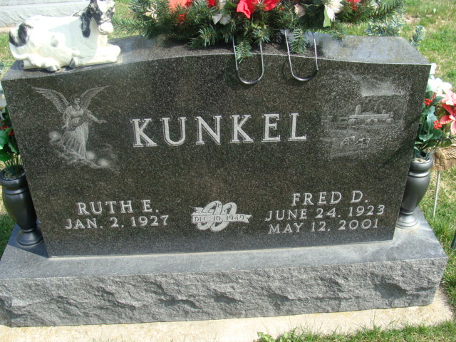
Photo by Alicia Kneuss

Ruth E. (Fuelling) Kunkel, 99 of Decatur, Indiana passed away at Adams Heritage in Monroeville, Indiana Tuesday evening, May 26, 2026. Ruth was born on January 2, 1927 in Adams County, Indiana to Fred E. and Elsie M. (Franz) Fuelling. She was married to Robert R. Reber in1945; he preceded her in death. Ruth was then united in marriage to Fred D. Kunkel on December 10, 1949 in Decatur, Indiana. They were happily married for 51 years. Fred preceded her in death on May 12, 2001.
Ruth was an active member of Zion Lutheran Church in Decatur, where she served on the Altar Guild and enjoyed counseling people through her training as a Stephen Minister. She also enjoyed her involvement with the Root Township Extension Homemakers where she served many years as an officer. Ruth also enjoyed volunteering in the 4-H Dining Hall.
She graduated from Monmouth High School in 1945 as valedictorian of her class. Ruth loved her family and her children were a priority. As her children became more independent, she worked in the cafeteria at Monmouth Elementary School for over 20 years. Ruth loved preparing and serving meals to the elementary students and had many co-workers and friends.
Ruth enjoyed gardening. Like most mid-century homemakers she canned and preserved everything she grew. She could always be seen helping Fred with the calves, dairy cows, driving tractor and baling hay. Ruth was an avid fan of Purdue basketball and never missed a game. Her greatest joy came from spending time with her children, grandchildren, great-grandchildren and great-great-grandchildren.
She is survived by daughter, Karen M. Heckman of Decatur, Indiana; son, Fred J. (Denise) Kunkel of Decatur, Indiana; daughter, Nancy J. Kunkel of Sudbury, Massachusetts; daughter, Emily R. (Ted) Porter of Decatur, Indiana; 16 grandchildren, Missy Helmick, Matt (Gina) Melcher, Jamie Melcher, Miranda (Kasey) Adams, Andy Melcher, Mike Heckman, Laura (Chad) Kukelhan, Becci Kunkel, Margaret (Adam) Holley, Hannah Kunkel, Adam (Jen) Romanow, Bobby (Katie) Romanow, David (Marta) Romanow, Danny (Katie) Porter, Chris Porter, Josh (Alexis) Porter; 25 greatgrandchildren; and nine great-great-grandchildren.
In addition to her husband, she was preceded in death by a daughter, Roberta (Bobbi) R. Melcher; great-grandson, Kirk Melcher; grandson, Fred W. Kunkel; son-in-law, Vernon Heckman; two brothers, Edgar C. & Fred W. Fuelling; and two sisters, Ellen Springer-Thieme and Dorothy DeLong.
A funeral service will be held at 10:00 a.m. on Tuesday, June 2, 2026, at Zion Lutheran Church in Decatur with Pastor Zachary Oedewaldt officiating. Burial will follow at Decatur Cemetery. Family and friends will be received from 2 to 7 p.m. on Monday, June 1, 2026, at Zion Lutheran Church in Decatur and from 9 to 10 a.m. Tuesday at the church.
Preferred memorials are to Zion Lutheran Church - Decatur or Adams County 4-H.

Zwick and Jahn Funeral Homes, Adams County, Indiana
June 5, 2026

