Lorna L. (Schaefer) Kukelhan
October 2, 1927 – June 25, 2024

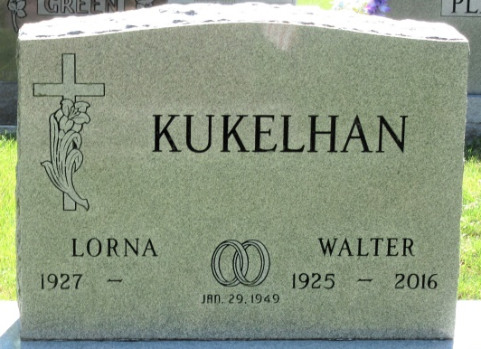
Photo by Alicia Kneuss

Lorna L. (Schaefer) Kukelhan, 96 of Fort Wayne and formally of Decatur, IN, passed away June 25th, 2024 surrounded by her loving family at Ashton Creek Health and Rehabilitation Center after a brief stay.
Born October 2, 1927 in Fort Wayne, IN, she was the daughter of Fred C. and Ella (Tielker) Schaefer. She was united in marriage to Walter A. Kukelhan, on January 29, 1949. They were married for 67 years before he passed away December 12, 2016.
Lorna retired from GE Decatur in 1988 after 38 years. She was a member of the GE Quarter Club and the O & O Extension Homemakers Club. She was a member of Zion Lutheran Church Decatur, where she was a member of the altar guild and Missionary society. Lorna loved quilting and made many beautiful quilts for family and friends. She also loved genealogy and spent countless hours researching family history. Walt and Lorna traveled across the USA, Canada and Alaska by RV. They also traveled to Germany. She loved exploring new places and making memories.
Lorna enjoyed gardening, cooking and baking. She was renowned for her pies, especially rhubarb. She was also a skilled card player. She would serve you a piece of pie, lull you into complacency and then beat you at Euchre. Her family is grateful for the many precious years they were able to share with her. Lorna will be deeply missed and forever remembered for her unwavering love for her family.
Special thanks to the staff and residents of Evergreen Village Assisted Living in Fort Wayne for loving and caring for mom the past three years.
Surviving are her children, David Kukelhan of Cleveland, OH; Philip Kukelhan of Cleveland, OH; daughter, Holly (Richard) Romary of Churubusco, IN; Jeff (Julie) Kukelhan of Decatur, IN; sister, Dina Swing of Ossian, IN; sister-in law, Dorothy Oetting of Ft. Wayne, IN; sister-in law, Alice Bauermeister of Ossian, IN; eight grandchildren, Joshua Kukelhan, Daniel (Liz) Romary, Ashley (Greg) Gotsch, Analisé (Tripp Handke) Kukelhan, Eric (Ashley Dionne) Romary, Janna (Eric) Gardner, Anna Kukelhan, and Jonas Kukelhan; and five geat-grandchildren, Asher Gotsch, Fisher Gotsch, Jacob Romary, Joanna Romary, and June Romary.
She was preceded in death by her parents; husband Walter; brothers, Marvin and Elmer Schaefer and daughter-in-law, Mary Weyburne-Kukelhan.
A funeral service will be held at 11:00 a.m. Wednesday, July 3, 2024 at Zion Lutheran Church in Decatur, with Pastor Zachary Oedewaldt officiating. Burial will follow in Decatur Cemetery. Family and friends will be received from 4-7 p.m. Tuesday, July 2, 2024, at the Zwick & Jahn Funeral Home in Decatur and one hour prior to the service on Wednesday at the church.
Preferred memorials are to Zion Lutheran Church, Decatur- Altar Guild; Worship Anew or Concordia Theological Seminary, Fort Wayne, Indiana.

Zwick & Jahn Funeral Home, Adams County, Indiana
July 4, 2024

