Debra A. (Brunner) Knittle
June 15, 1954 - June 30, 2024

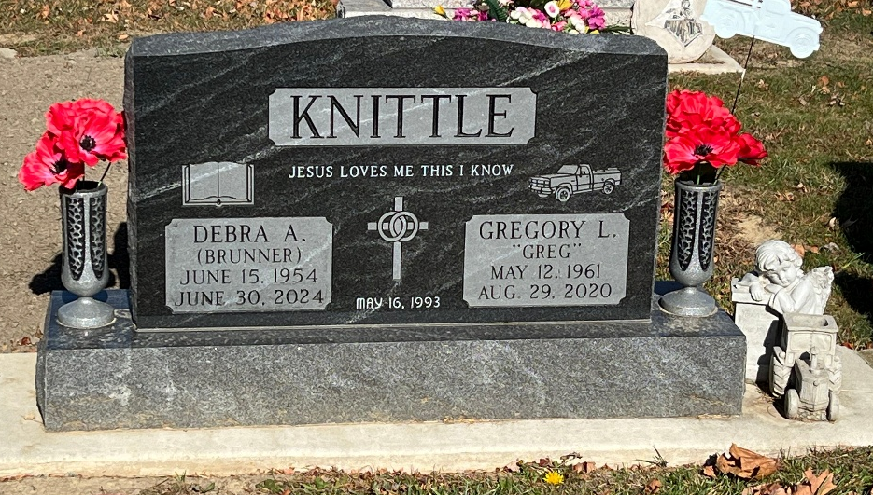
Photo by Deb Curry

Debra A. Knittle, 70, of Decatur, Indiana passed away Sunday, June 30, 2024, at Lutheran Hospital in Fort Wayne, Indiana. She was born on June 15, 1954, in Decatur, Indiana to the late John P. Brunner and Phylliss (Elliott) Brunner. Debra was united in marriage to Gregory L. Knittle on May 16, 1993, in Decatur, Indiana and he preceded her in death on August 29, 2020.
Debra was a member of Mt. Victory United Brethren in Christ Church of rural Decatur. She was a hard worker and loved working with the public. Over the years she served in many capacities for different companies, and always looked forward to getting up in the morning and going to work. Reading was her favorite thing but above anything else she loved her family and spending time with them.
She is survived by a daughter, Elizabeth (Jeffrey) Adams of Easley, South Carolina, son, Patrick (Tasha) Knittle of Fort Wayne, Indiana; daughter, Sasha Knittle of Geneva, Indiana; mother, Phyllis Brunner of Decatur, Indiana; brother, Denny Brunner of Decatur, Indiana; sister, Donna (Mike) Mahan of Decatur, Indiana; brother, David (Sarah) Brunner of Huntington, Indiana; sister, Deana (Clinton) Alexander of Warsaw, Indiana; 11 grandchildren, Taya (Caleb) Averill, Brielle Adams, Liam Adams, Lisle Knittle, Logan Knittle, Braden Knittle, Chloe Knittle, Gabriella Knittle, Raigan Brandt, Carson Knittle, and Anthony Knittle; two great-grandchildren, Maple Mae Averill and Maverick Harley Averill.
Debra was preceded in death by one son; Anthony “Tony” Knittle and one grandson; Bryson Knittle.
A funeral service will be held at 2:00 p.m. Saturday, July 6, 2024, at the Zwick & Jahn Funeral Home in Decatur, Indiana with Pastor Ed Gebert officiating. Burial will follow at Decatur Cemetery. Family and friends will be received two hours prior to the service at the funeral home on Saturday.
Preferred memorials are to Mt. Victory United Brethren in Christ Church or Riley Children’s Hospital.

Zwick and Jahn Funeral Homes, Adams County, Indiana
July 4, 2024

