Vida Edna (Bowers) Kaough
June 5, 1886 – January 31, 1973

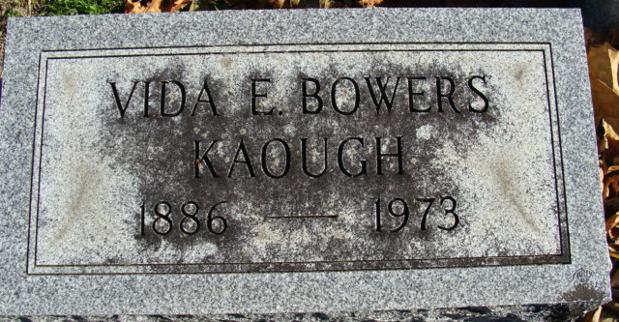
Photo by Alicia Kneuss

Vida E. Kaough taken by death this morning
Vida E. Kaough, 86, of Fort Wayne, a resident of Decatur for 32 years, died at 8:35 a.m. today at Crow’s Haven Nursing Home in Fort Wayne, where she had been a patient one week. Mrs. Kaough had been in failing health for the past year.
She was born in Decatur on June 5, 1886 to John S. and Mary E. Lamon-Bowers, who are deceased. She resided at 104 Marshall Street in Decatur for 32 years prior to moving to Fort Wayne.
Surviving are two sons, Clifford D. Robinson of Fort Wayne and John Edwin Kaough of Decatur; and two sisters, Miss Esther Bowers of Decatur and Mrs. Ruth B. Gill of West Palm Beach, Fla., along with a sister-in-law, Mrs. Florence Bowers of Geneva, N.Y.
Funeral services will be conducted at 10:30 a.m. Friday in Zwick Funeral Home, Decatur. Rev. William C. Feller will officiate. Burial will follow in the Decatur Cemetery. Friends may call at the funeral home after 2 p.m. Thursday. Preferred memorials are to the Cancer Fund.
Decatur Daily Democrat, Adams County, Indiana
Wednesday January 31, 1973

