Bessie Rhoda (Wilder) Kain-Turner
March 16, 1897 – November 13, 1959

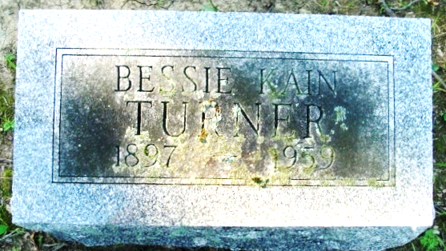
Photo by Alicia Kneuss

Funeral services will be held at 1 pm Monday at the D.O. McComb & Sons Funeral Home for Mrs. Bessie Kain Turner, 62, 4821 Palatine Dr., who died at 1:30 am Friday at the Lutheran Hospital where she had been a patient five weeks. The Rev. A. Hunter Colpitts will officiate and burial will be in the Maplewood Cemetery in Decatur.
She was born in Monmouth and lived here 40 years. She was an employee of Hutner’s. Mrs. Turner was a member of the Crescent Avenue Evangelical United Brethren Church and American Legion Auxiliary of Post 47.
Surviving are the husband, Grover H.; a son, John F. Kain, Berkeley, Calif.; a daughter, Mrs. Richard Shaw, East Longdale, Calif., three sisters, Mrs. Lance T. Johnsbo, Findlay, O., Mrs. Richard Harkless, Decatur and Mrs. M. G. Buckley, Fort Wayne.
Friends may call at the funeral home today. The Auxiliary to Post 47, American Legion, will conduct services at 7:30 pm Sunday at the funeral home. Memorials to the Crescent Avenue EUB Church are preferred by the family.

Journal-Gazette, Allen County, Indiana
November 14, 1959
Page 2
**

Indiana, U.S., Marriages, 1810-2001
Name Bessie Rhoda Wilder
Gender Female; Race White
Age 22
Event Type Marriage Registration (Marriage)
Birth Date 16 Mar 1897
Birth Place Monmouth, Indiana
Marriage Date 18 Oct 1919
Marriage Place Indiana, United States
Residence Place Monmouth, Indiana
Father Chancey C Wilder
Mother Winnie Watts
Spouse Forest M Kain
Page 4; FHL Film Number 002321630
**
Indiana, Death Certificates, 1899-2011
Name: Bessie Kain Turner
[Bessie Kain Widler]
Gender: Female
Race: White
Age: 62
Marital Status: Married
Birth Date: 16 Mar 1897
Birth Place: Monmouth, Indiana
Death Date: 13 Nov 1959
Death Place: Fort Wayne, Allen, Indiana, USA
Father: Chauncey Widler
Mother: Winnie Watts
Informant: Grover H. Turner; husband; Ft. Wayne, Ind.
Burial: Nov. 16, 1959; Maplewood Cem., Decatur, Ind.

