Phillip A. Juengel
March 24, 1937 – November 28, 2023

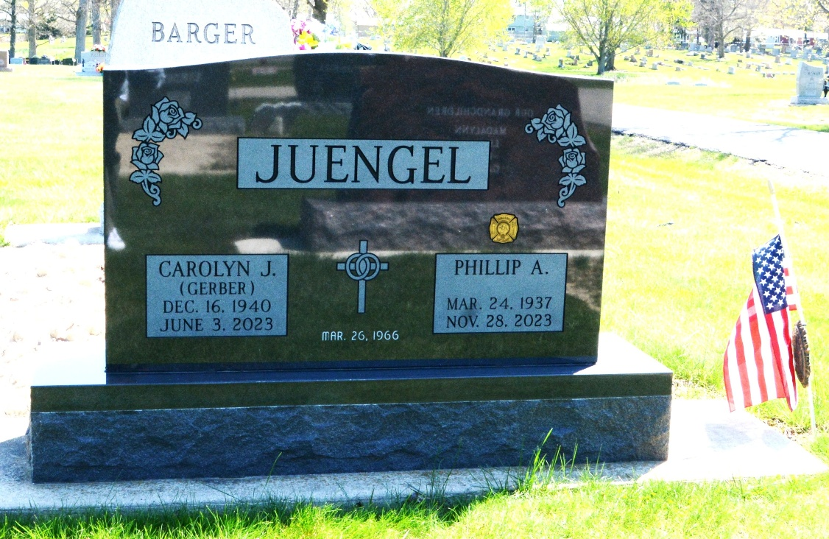
Photo of Deb Curry
Phillip A. “Phil” Juengel, 86, of Preble, Indiana passed away Tuesday evening, November 28, 2023, at Adams Woodcrest in Decatur. He was born on March 24, 1937, in Avilla, Indiana to the late Martin and Edna (Weimer) Juengel. Phil was united in marriage to Carolyn Jean Gerber on March 26, 1966, at the First Mennonite Church in Berne and she preceded him in death on June 3, 2023.
Phil served his country in the United States Army from 1958 to 1962.
He was a member of Zion Lutheran Church in Decatur, where he served the Lord for many years as an usher. He was a member of the Northeastern Indiana Beekeeper Association, the American Beekeeping Federation, and the Indiana State Beekeepers Association. He was a volunteer with the Preble Volunteer Fire Department, a member of the Indiana Volunteer Fire Department Association, and a member of the American Legion Post #43.
Phil graduated from Avilla High School in 1955 and went on to attend Midwestern College in Fort Wayne. He was employed for over 37 years as a tool & die designer for CTS in Berne, where he retired in 2002.
He was an active beekeeper in Adams County for many years. He enjoyed gathering honey and helping his wife, Carolyn, in making candles for sale at area festivals.
Phil is survived by a son, Kenneth Juengel of Christmas Valley, Oregon; son, Timothy (Emily) Juengel of Cincinnati, Ohio; son, Steven (April) Juengel of Plainfield, Indiana; son, Mark (Darlene) Juengel of Decatur, Indiana; brother-in-law, Art Grawcock of Avilla, Indiana; 12 grandchildren, Jason Juengel, Jean Smith, James Juengel, Rose Juengel, Lucas Juengel, Abbigail Juengel, Courtney Juengel, Bridget Juengel, Samuel Juengel, Zachary Juengel, Emma Juengel, and Theodore Juengel; and several great-grandchildren.
He was preceded in death by his son, Craig Juengel in infancy, and his two sisters, Lillian Peters and Esther Grawcock.
A funeral service for Phil will be held at 10:00 a.m. Monday, December 4, 2023, at Zion Lutheran Church in Decatur, Indiana with Pastor Zachary Oedewalt officiating. Burial will follow at Decatur Cemetery with Military Honors being rendered by the United States Army and the American Legion Post #43. The family will receive friends from 1:00 to 5:00 p.m. Sunday, December 3, 2023, at the Zwick & Jahn Funeral Home in Decatur, Indiana, and one hour before the service at the church.
Preferred memorials are to Zion Lutheran Church or Preble Volunteer Fire Department.

Zwick & Jahn Funeral Home, Adams County, Indiana
November 28, 2023

