Carolyn Jean (Gerber) Juengel
December 16, 1940 – June 3, 2023

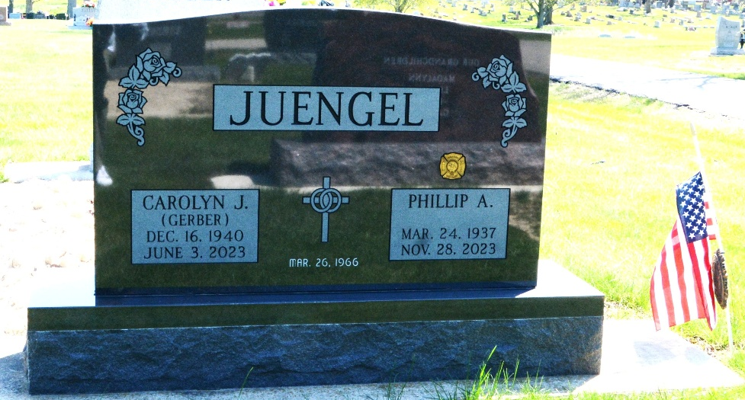
Photo by Deb Curry

Carolyn Jean Juengel, 82, of Preble, Indiana passed away Saturday afternoon, June 3, 2023, at Adams Woodcrest in Decatur, Indiana. She was born December 16, 1940, in Adams County, Indiana to the late Milton Gerber and the late Rhoda (Lehman) Gerber. Carolyn was united in marriage to Phillip Juengel on March 26, 1966, at First Mennonite Church in Berne, Indiana, and he survives.
Carolyn was a member of Zion Lutheran Church in Decatur, where she was active in the church choir, Altar Guild, and was a Sunday School teacher for many years. She was also a member of the Preble Volunteer Fire Department Auxiliary. Carolyn also served as a previous President of Hoosier Honey.
She graduated from Geneva High School in 1958. She then worked at Dunbar Furniture and CTS in the accounting departments. She was also the relief postmaster for Preble for a number of years. Carolyn then went on to be a bus driver for special needs students at North Adams Community Schools, where she retired after 14 years in July of 2010.
Carolyn enjoyed helping her husband make candles for bee-keeping festivals around the area. She enjoyed spending time outside tending to her garden and flowers. Above all, she loved spending time with her grandchildren making sure they always had cookies to eat.
She is survived by her husband of 57 years, Phillip Juengel of Preble, Indiana; son, Kenneth Juengel of Christmas Valley, Oregon; son, Timothy (Emily) Juengel of Cincinnati, Ohio; son, Steven (April) Juengel of Plainfield, Indiana; son, Mark (Darlene) Juengel of Decatur, Indiana; sister, Marjorie (Thomas) Mills of Brookville, Ohio; sister, Nancy Gerber of Cincinnati, Ohio; sister, Karen (Greg) Rabus of Mt. Prospect, Illinois; brother, Dennis (Nyla) Gerber of Geneva, Indiana; 12 grandchildren, Jason Juengel, Jean Smith, James Juengel, Rose Juengel, Lucas Juengel, Abbigail Juengel, Courtney Juengel, Bridget Juengel, Samuel Juengel, Zachary Juengel, Emma Juengel, and Theodore Juengel; and several great-grandchildren.
Carolyn was preceded in death by a son, Craig Juengel in infancy, and a sister, Ruth Ann Grossman.
A funeral service will be held at 2:30 p.m. Wednesday, June 7, 2023, at Zion Lutheran Church in Decatur with Pastor Zachary Oedewaldt officiating. Burial will follow in the Decatur Cemetery. The family will receive friends from 3:00 to 5:00 p.m. and 6:00 to 8:00 p.m. Tuesday, June 6, 2023, at the Zwick & Jahn Funeral Home in Decatur and also one hour prior to the service on Wednesday at the church.
Preferred memorials can be made to Zion Lutheran Church or the Preble Volunteer Fire Department.

Zwick & Jahn Funeral Home, Adams County, Indiana
June 5, 2023

