Marilyn Louise (Egly) Johnson
April 24, 1935 – April 18, 2025

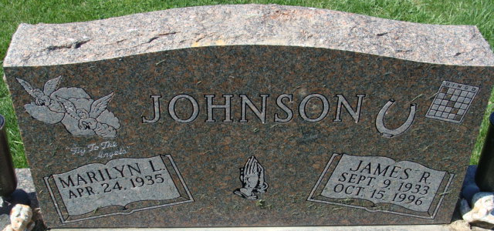
Photo by Alicia Kneuss

Marilyn L. Johnson, 89, of Decatur, Indiana, passed away on Friday, April 18, 2025, at Canterbury Villa in Alliance, OH. Marilyn, daughter of the late Homer E. and Cecile W. (Resh) Egly, was born on April 24, 1935, in Waynedale, IN. On November 12, 1953, Marilyn married James R. Johnson. He preceded her in death on October 15, 1996.
Marilyn was a member of St. Mark's Church Decatur where she was a Sunday School Teacher and taught pre-school at the church. She was employed by Kmart for 23 years and retired in 1997. She worked part-time at the Adams County Treasurer Office and at Hardees. She volunteered at Adams Memorial Hospital and St. Vincent de Paul. Marilyn was also a former member of the Moose. Marilyn was a loving wife, mother and grandmother. She enjoyed visiting with family and friends; loved her dog, Benji; going to the lake, playing bingo and crocheting.
She is survived by her 6 children, Penny (Dave) Doty of New Haven, IN, Becky (Dave) Masterson of Berne, IN, James (Ed) (Nan) Johnson of Alliance, OH, Michael (Ellen) Johnson of Decatur, IN, Randall (Susie) Johnson of Rome City, IN, Robert (Sheba) Johnson of Geneva, IN; 19 grandchildren, 20 great grandchildren, and 6 great-great grandchildren.
Marilyn was preceded in death by a daughter, Sandra K. Kolter; 2 grandsons, Phillip Johnson and Randy Weiland; siblings, Earl Baker and Mary Morence.
Visitation will be from 4:00 – 7:00 p.m. Thursday, April 24, 2025 at Haggard-Hirschy & Zelt Funeral Home. A Funeral Service will be held on Friday, April 25, 2025, at 2:00 p.m. also at the funeral home with calling 1 hour prior from 1:00 – 2:00 p.m. Pastor David Reed officiating and burial will follow in Decatur Cemetery.
Preferred memorials can be made to St. Mark's Church or Canterbury Villas, Alliance, OH.

Haggard Hirschy & Zelt Funeral Home, Adams County, Indiana
Apr. 22, 2025

