Albert L. Huston
October 19, 1933 – May 17, 2024

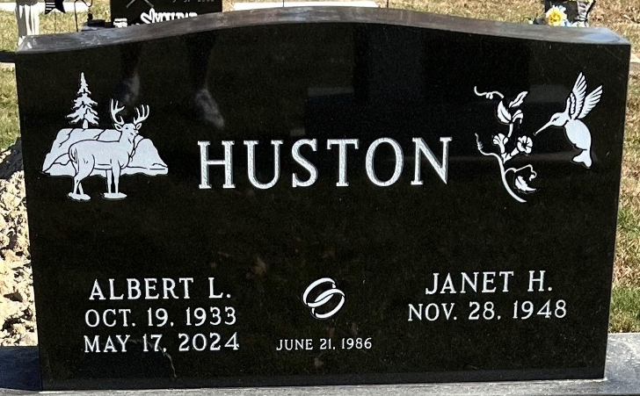
Photo by Deb Curry

Albert L. Huston, 90, of Celina, Ohio passed away Friday, May 17, 2024, at his residence. He was born on October 19, 1933, in Decatur, Indiana to the late William Huston and C. Marie (Hilton) Huston.
Al was united in marriage to Janet Miller on June 21, 1986, and she survives.
He was a member of Rockford Belle Community Church in Rockford, Ohio. Al retired from G.E. in Decatur, after 36 years of service. He loved to hunt, fish, playing golf, bowling, antiquing, and collecting guns and Indian artifacts.
Wife, Janet Huston of Celina, Ohio; son, Ron Huston of Monroeville, Indiana; daughter, Pam Huston of Decatur, Indiana; daughter, Denise (Dave Castle) Huston of Monroeville, Indiana; daughter, Sherri (Randy) Waltmire of Celina, Ohio; nine grandchildren, Jeremy Huston, Jessica Gilbert, Zackary Caffee, Jacob Caffee, Josh Waltmire, Dustin Huston, Danielle Jones, Colin Waltmire and Alex Waltmire; 11 great-grandchildren and one great-great-granddaughter.
He was preceded in death by a brother, William Huston; a sister, Francis Thatcher.
A funeral service will be held at 3:00 p.m. on May 22, 2024, at Zwick & Jahn Funeral Home in Decatur with Pastor Dana Smith officiating. Burial will follow at the Decatur Cemetery. Friends and family will be received from 11:00 a.m. – 3:00 p.m. on May 22, 2024, at Zwick & Jahn Funeral Home in Decatur.
Preferred memorials to EverHeart Hospice and Rockford Belle Community Church in Rockford, Ohio.

Zwick & Jahn Funeral Home, Adams County, Indiana
May 18, 2024

