Cpl. John H. Hurst
December 7, 1882 – August 8, 1900

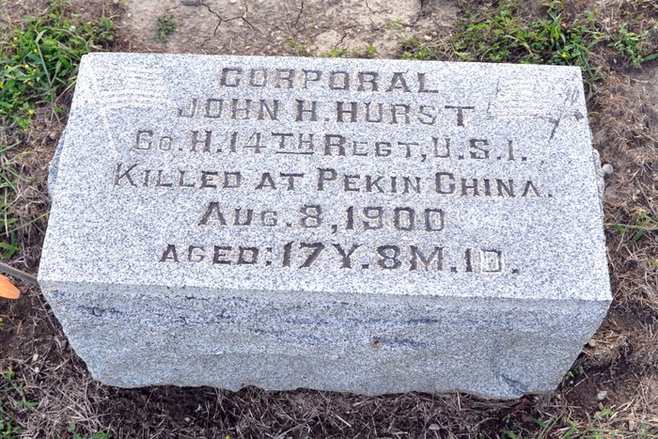
Photo by Deb Curry

DEAD IN CHINA –

In casualty list from China today is the following paragraph: Private John H. Hurst, Company H. Fourteenth Infantry, killed August 16 at Tien Tsiu. He enlisted at Jeffersonville, Ind., and his nearest relative is James Hurst, of Decatur, Ind.

Evening News, Jeffersonville, Indiana
August 30, 1900

**
The last bugle has sounded over the remains of Corporal Harry Hurst and yesterday his friends and comrades did homage to his memory, as with slow and measured tread they followed his inanimate body to its last resting place beneath the sod of beautiful Maplewood. The tragic death of this young hero at Tien Tsin is still fresh in the minds of all, at the head of his company he was fighting bravely for his country and flag, when a bullet from the gun of an ally pierced his head and he fell mortally wounded, expiring three days afterwards without even gaining consciousness. The battle occurred July 5, 1900 and his remains did not arrive until Monday morning of this week.
Yesterday services were indeed appropriate of his valiant deeds and his memory will ever be cherished in the minds of all. He was a brave and fearless soldier and would have no doubt won success had his life been spared. The funeral was held from the Methodist church yesterday morning, Rev. C. G. Hudson conducting, assisted by Rev. E. H. Peters, who delivered the sermon. Members of Co. B, 160th regiment took charge of the casket at the church and conducted services at the grave in a truly military manner.

Decatur Democrat, Adams County, Indiana
A weekly newspaper
Thursday, January 31, 1901

**
The remains of Harry Hurst, the soldier boy who lost his life at Tien Tain, China, will arrive here either Sunday or Monday morning. A telegram from the officer in charge at San Francisco, was received by the boy's father, James Hurst, yesterday announcing that the body left there Tuesday evening at six o'clock via the Wells Fargo Express lines. Arrangements are being made for the funeral services which will be held at the Methodist Church some time next week, probably not until a week from Sunday. Undertaker Gay will have charge of the body.

Decatur Democrat; Adams County, Indiana
Thursday, January 24, 1901

**
All Spanish-American War soldiers are requested to meet at the Amspaugh & Kittson barber shop Friday evening at 8 o'clock to make arrangements to attend the funeral of Harry Hurst.

Decatur Democrat; Adams County, Indiana
Thursday, January 24, 1901

**
The funeral services yesterday over the remains of Corporal J. H. Hurst were beautiful and were largely attended. Revs. Hudson, Peters, Kline and Duckett conducted the same.

Decatur Democrat; Adams County, Indiana
Thursday, January 31, 1901

**
John H Hurst from tree Miller Family Tree
Birth 7 Dec 1882 Indiana, USA
Residence 1900 Adams, Indiana, USA
Death 8 Aug 1900
Father James Hurst (1854-1947)
Record information.
Mother Mary Mallisa Fisher (1859-1949)
*
U.S. National Cemetery Interment Control Forms, 1928-1962
Hurst, John H.
Rank: Pvt; Co. H; 14th US Inf.
Death: Aug. 9, 1900 in China
Remarks: Recd, S. F. on "California" 1/13/01 and shipped Jno. Hurst, Decatur, Ind., # 154833
Info taken from Old Cards 11/15/50 JBK

