Jessie R. Hurst
January 22, 1967 – October 25, 2020

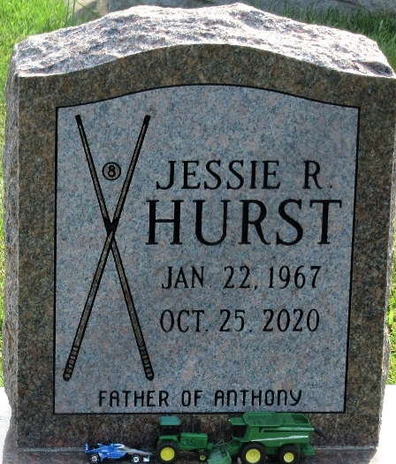
Photo by PLS

Jessie R. Hurst, 53, of Marion, IN, formerly of Decatur, passed away at his residence on Sunday, October 25, 2020. He was born in Adams County, IN, on January 22, 1967, the son of Mike and Dorothy (Brodbeck) Hurst. Raised by his uncle and aunt, Glen and Donnabelle Geyer. On September 10, 2020, he married Salinda Nash.
He was a member of Grace Fellowship Church.
Jessie is survived by his wife, Salinda Hurst of Marion; his uncle, Glen Geyer of Decatur; a son, Anthony Hurst of Decatur; a brother, Kim Hurst of Decatur; 2 cousins, Butch Affolder and Linda Lose. Jessie was “Pappy” to 10 grandchildren that will miss him greatly.
A Funeral Service will be held at 1:00 p.m. on Thursday, October 29, 2020, at Haggard-Sefton-Hirschy & Zelt Funeral Home, with a visitation 2 hours before from 11:00 a.m. – 1:00 p.m. Pastor Dan York will be officiating and burial will take place at Decatur Cemetery.
Memorials may be made to Riley Children’s Hospital.

Haggard & Sefton Funeral Home, Adams County, Indiana
October 26, 2020

