Barbara Ellen (Calvin) Hower
December 25, 1827 – January 17, 1899

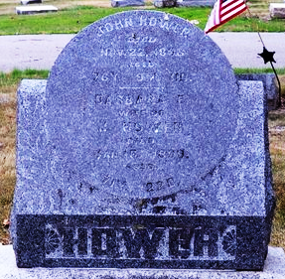
Photo by Deb Curry

Mrs. John Hower, a pioneer lady of the county, died at her home in Kirkland Township, Monday evening, aged seventy-two years.
Funeral services were conducted at the Methodist Church in this city yesterday afternoon, Rev. Daniel officiating.
Her husband, John Hower, preceded her to the Heaven of rest about two months ago.
A large circle of friends and relatives mourn the death of a kind and loving woman.

Decatur Democrat, Adams County, Indiana
Thursday, January 19, 1899

**
Death of Mrs. John Hower

The death of Mrs. John Hower, occurred at about twelve o’clock last night, at her residence in Kirkland Township. She was in the neighborhood of 70 years of age, and the funeral will be held in the Decatur M. E. Church tomorrow at one o’clock. Her husband’s funeral took place from the same church, November 25th last.

Decatur Weekly Journal, Adams County, Indiana
Friday, January 20, 1899

**
Barbara A. Calvin was born in Clark County, Ohio, December 24,1827; was married to John Hower in Champaign County, Ohio, December 4, 1845, and died at her home in Adams County, Ind., January 17, 1899, at the age of 72 years and 23 days.
She united with the Methodist Episcopal Church in her youth, and has lived a faithful Christian life, and expressed a perfect willingness to die.

Decatur Weekly Journal; Adams County, Indiana
Friday, January 20, 1899

**
The last will and testament of Barbara Ellen Hower, deceased, was probated at the clerk's office last Friday. It bequeaths all real and personal property to her son, William D. Hower.
Decatur Democrat, Adams County, Indiana
Thursday, January 26, 1899

