Jon L. Howard
August 14, 1954 – December 21, 2017

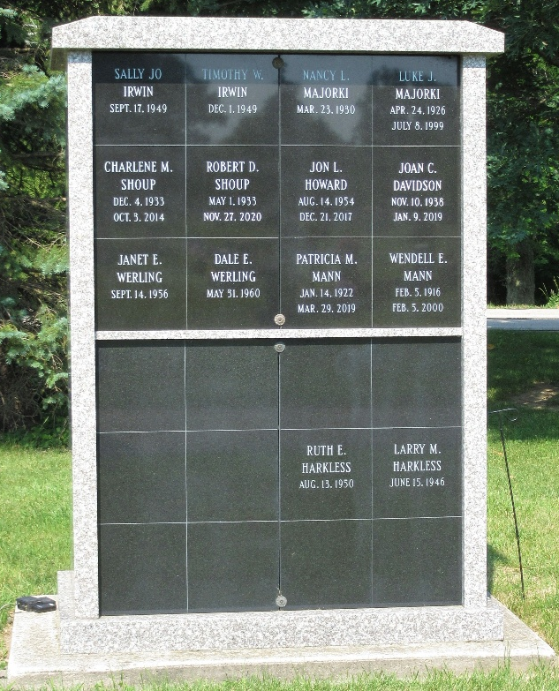 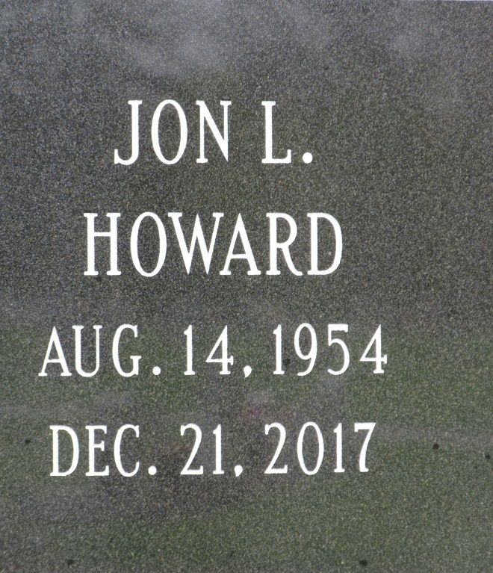
Jon L. Howard, 63, of Decatur, IN passed away Thursday, December 21, 2017 at his residence. He was born on Saturday, August 14, 1954 in Decatur the son of the late Ivan Howard and the late Donna (Berger) Howard.
Jon was a former brick mason and was a former member of the Bricklayers Union in Ft. Wayne.
Survivors include his brother, Richard (Sheryl) Howard of Decatur, IN. Jon is preceded in death by his son Joshua Garnett.
In following Jon's wishes, cremation was chosen with no visitation or funeral services.

Zwick & Jahn Funeral Home, Adams County, Indiana
December 22, 2017

