Hannah Sophia (Sodtman) Homeier
February 5, 1872 – February 2, 1969

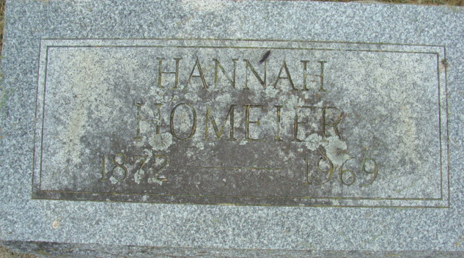
Photo by Alicia Kneuss

Hanna Homeier Dies Last Evening
Mrs. Hanna Homeier, 96, of 121 North 10th Street, oldest member of the Zion Lutheran Church in this city, died at 8:30 p.m. Sunday at the Lutheran Homes, Inc., Fort Wayne. Death followed an extended illness.
She was born in Avilla Feb. 5, 1872, a daughter of Fred and Margaret Weimer-Sodtman. Her husband, Fred Homeier, preceded her in death in 1906.
Mrs. Homeier was a member of the Zion Lutheran Church and the Missionary Society of the church.
Surviving is one daughter, Mrs. Carl (Alvena) Smith of Decatur; one grandson, Murray Gordon of Long Beach, Calif.; two great-grandchildren, and three great-great-grandchildren. One daughter and one son are deceased.
Funeral services will be conducted at 1:30 p.m. Wednesday at the Zwick Funeral Home, with Rev. Paul W. Ludwig officiating. Burial will be in the Decatur Cemetery. Friends may call at the funeral home after 2 p.m. Tuesday until time of the services.

Decatur Daily Democrat, Adams County, Indiana
Monday, February 3, 1969

**
Indiana, U.S., Death Certificates, 1899-2011
Name: Hanna Homeier
[Hanna Sodtman]
Gender: Female
Race: White
Age: 96
Marital status: Widowed
Birth Date: 5 Feb 1872
Birth Place: Indiana
Death Date: 2 Feb 1969
Death Place: Fort Wayne, Allen, Indiana, USA
Father: Fred Sodtman
Mother: Margaret Weimer
Informant: Mrs. Carl Smith; daughter; Decatur, Indiana
Burial: February 5, 1969; Decatur Cemetery; Decatur, Indiana

