Steven Lynn Holloway
April 5, 1940 – June 23, 2024

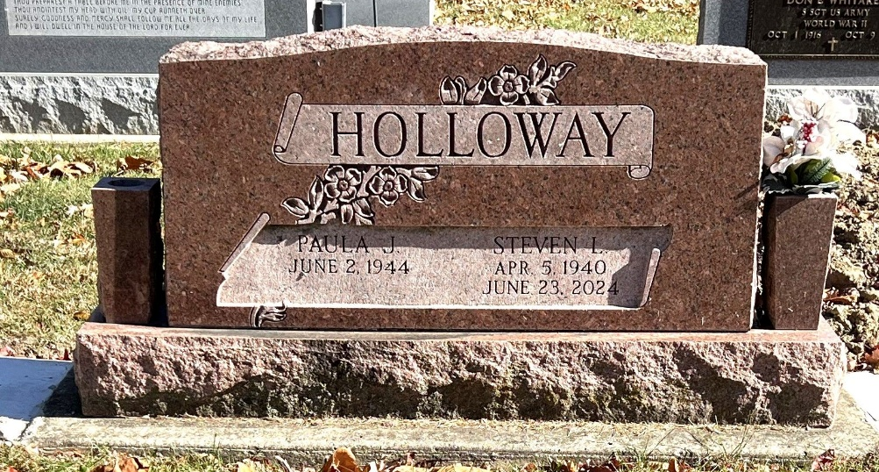
Photo by Deb Curry

Steven L. Holloway, 84, of Decatur, Indiana passed away Sunday, June 23, 2024, at Lutheran Hospital of Fort Wayne. He was born on April 5, 1940, in Adams County, Indiana to the late Howard Clayton Holloway and Jenny Pauline (Shoe) Holloway. Steve was united in marriage to Paula J. Morgan on March 28, 1994.
He was a former member of the Decatur Lions Club. Steve began his employment with International Harvester in 1962 and retired from Navistar in June 1999. He loved fishing and just spending time outdoors.
Steve is survived by his wife, Paula Holloway of Decatur, Indiana; daughter, DeeAnna Orahood of Marysville, Ohio; step-daughter, Davena Reasoner of Campbellsburg, Indiana; step-daughter, Lisa Werling of Decatur, Indiana; step-son, Rob Killian of Butler, Indiana; sister, Nondes Holloway of Greentown, Indiana; sister, Roberta (Ken) Steffen of Bluffton, Indiana; sister, Ellen (Jim) Harris of Greentown, Indiana; sister, Linda (Dave) LaRowe of Old Hickory, Tennessee; sister, Paula (Bruce) Shrock of Greentown, Indiana; six grandchildren, Rachel Reasoner, Adem Reasoner, Zackary Orahood, Emma Orahood, Tyler Cress, and Andrew Cress and three great-grandchild-ren, Madison Irwin, Vaeda Minkosky, and Dallas Reasoner.
He was preceded in death by a sister, Marlene Holloway; and a brother, Gordon Holloway
A funeral service will be held at 2:00 p.m. June 27, 2024, at the Zwick & Jahn Funeral Home in Decatur, Indiana with Pastor Harold Klinker officiating. Burial will follow at Decatur Cemetery. Friends and family will be received two hours prior to the service at the funeral home on Thursday.
Preferred memorials are to the Decatur Lions Club.

Zwick & Jahn Funeral Home, Adams County, Indiana
July 4, 2024

