Martha Anna Maria (King) Hofer
June 15, 1899 – August 24, 1923

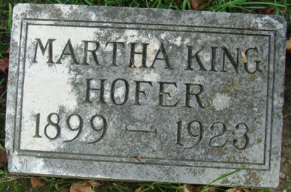
Photo by Alicia Kneuss

Decatur – Martha Ann King, 24 years old, orphan daughter of Mr. and Mrs. Elias King died at the home of Mr. and Mrs. J. J. Hofer in Monroe following an illness of long duration of tuberculosis of the bowels.
Two half-sisters and one half-brother survive.

Unknown source

**
The subject of this sketch, Miss Martha Anna M. King Hofer, daughter of Elias and Anna King, was born in Adams County, near Monroe, Ind., June 15, 1899. Her parents both passed into the beyond within 19 months after her birth. The admittatur soon succeeded in finding a home for the child with Mr. and Mrs. J.J. Hofer, who lived here and cared for her as their own.
Her religious nature was awakened early in life. As soon as she understood, she expressed a desire to be baptized. She was accordingly baptized and united with the Monroe M. E. Church Jan. 11, 1911, under the labors of J. Hanchmar. She dates her conversion however to Jan. 21, 1911. She has continued faithful in the Christian life to the time of her death. She was a good Christian girl, and lived a clean, simple life of faith. She was enabled by grace and faith to speak of her departure which she knew was near at hand, as “going away.” Only Christians can face death so calmly as that. For her death had lost its sting, because her Savior conquered death.
She passed away after a lingering illness on August 28, 1923, aged 24 years, 2 months and 13 days. She leaves to mourn her: foster parents, Mr. and Mrs. J. J. Hofer; two sisters, one brother, and a large circle of more distant relatives and friends.
Funeral serves were conducted from the Methodist Episcopal Church in Monroe on Friday, August 31, at 2 o’clock, by her pastor, Rev. S. I. Zechiel. The scripture lesson and the text, and the songs were of her own selection. Interment was at Decatur.
Decatur Daily Democrat, Adams County, Indiana
Wednesday, September 5, 1923

**
Indiana, U.S., Death Certificates, 1899-2011
Name: Martha Anna M King
Gender: Female
Race: White
Age: 24
Marital status: Single
Birth Date: 15 Jan 1899
Birth Place: Washington TP Adams Co Ind
Death Date: 24 Aug 1923
Death Place: Monroe, Adams, Indiana, USA
Father: Elias King
Mother: Roxyann Carpenter
Informant: John E. Nelson; Monroe, Indiana
Burial: August 31, 1923; Decatur Cemetery

