James “Logan” Hockenberry
January 4, 1995 – October 3, 2024

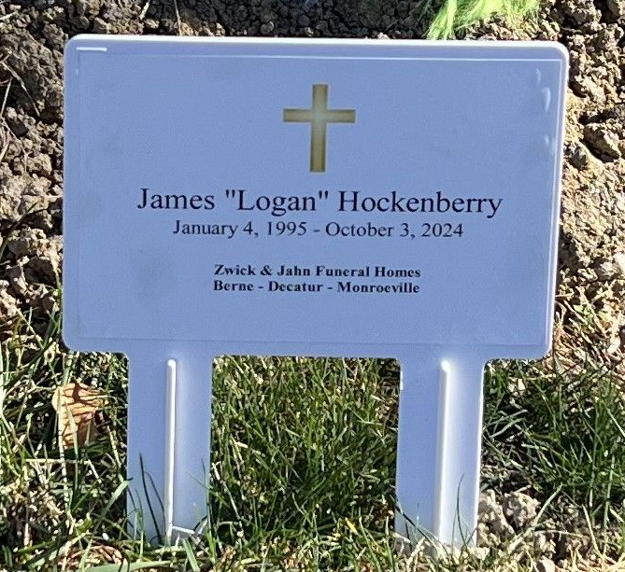
Photo by Deb Curry

James “Logan” Hockenberry, 29, of Hoagland, Indiana passed away on Thursday, October 3, 2024, at his residence. He was born on January 4, 1995, in Fort Wayne, Indiana to Steven and Sharon (Ball) Hockenberry.
Logan was a graduate of Heritage High School class of 2013, and was an Eagle Scout. He was previously employed at McMahon Tire Center in Fort Wayne, Indiana where he was a tire technician. Logan enjoyed playing video games, drawing, and carving pumpkins with his son and nieces and nephews.
Survivors include his parents, Steven & Sharon Hockenberry of Hoagland, Indiana; son, Jaxs Hockenberry of New Haven, Indiana; brother, Shane (Jenn) Hockenberry of Fort Wayne, Indiana; sister, Bobbi Hockenberry of Bluffton, Indiana; maternal grandmother, Marti Ball of Hoagland, Indiana; paternal grandmother, Rosalee Hockenberry of Fort Wayne, Indiana; many nieces, nephews, and aunts and uncles along with his loving Callie Cat and Monkey.
Logan was preceded in death by his maternal grandfather, James “Logan” Ball; paternal grandfather, Tom Hockenberry; cousin, DJ Oliver; and two uncles Bill & Tom Hockenberry.
A funeral service will be held at 10:30 a.m. Monday, October 14, 2024, at the Zwick & Jahn Funeral Home, Decatur with Pastor Wayne Ball officiating. Burial will follow in the Decatur Cemetery. Family and friends will be received from 12 noon- 5:00 p.m. Sunday, October 13, 2024, at the Zwick & Jahn Funeral Home, Decatur and one hour prior to the service on Monday.
Preferred memorials can be given to the family - checks payable to Zwick & Jahn Funeral Home.

Zwick and Jahn Funeral Homes, Adams County, Indiana
October 5, 2024

