Richard Lee Herman
January 10, 1938 – July 2, 1970

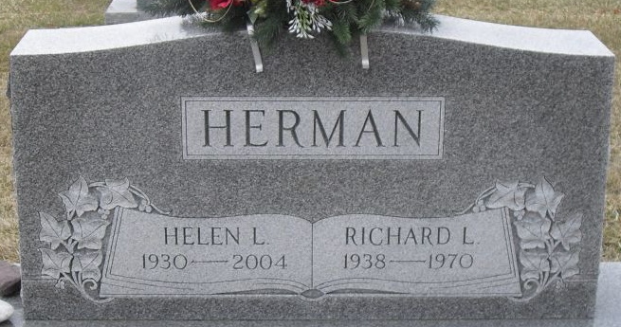
Photo by Stephen & Andrea Brangan

Decatur Truck Driver Dies in Collision East of Decatur Thursday

A Decatur resident, Richard L. Herman, 33, of 327 Bollman Street., was killed early Thursday afternoon when the big rig he was driving for the Automatic Sprinkler Corp., Monroe, went out of control after striking a car, flipped over on its top, and skidded into a field east of Decatur on U.S. Highway 224. The fatal mishap occurred at approximately 12:34 p.m. three miles east of Decatur at the inter-section of U. S. Highway 224 and State Road 101.
According to Adams County Coroner Richard Linn, Herman died as the result of a crushed chest and ruptured liver. Herman was pinned inside the wreckage for approximately 20 minutes, and it took two wreckers to pry him from the cab.
Pulls In Front
According to Adams County Sheriff Roger L. Singleton and State Trooper Gene Rash, who investigated the accident, a car operated by Forest G. Hibler, 74, of Fort Wayne, southbound on 101, pulled directly in front of a westbound truck on 224 loaded with tons of steel, operated by Herman. Hibler told the Sheriff’s Department and State Police that he stopped for the stop sign, but then pulled out into the intersection, apparently not seeing the truck.
Hibler received a laceration to the scalp as the result of the accident and was treated at the Adams County Memorial Hospital, and then released this morning.
After the truck struck the auto on the left side, back by the rear bumper, the rig continued down the highway in the right lane for approximately 100 feet, but then swerved to the left, and before it went off the roadway, the cab turned over on its top, and then skidded 90 feet into a field which is part of the landing strip at the Decatur Hi-Way Airport.
Some of the steel piping spilled out of the truck’s trailer, and one of the pipes struck the tires of an eastbound car driven by Love Zelno Woods, 79, of Route 2, Ohio City, O., causing both tires to blow out, and damaging both wheels. He had just witnessed the accident ahead and was almost stopped in the lane of traffic when the big pipe struck his auto.
The Decatur Fire Department was called to the scene to stand by in case of fire, and wreckers from Sheets’, Barker’s and State Line Auto helped at the accident scene. Members of the Decatur Police Department also helped direct traffic at the accident scene.
Adams County now has recorded two traffic fatalities in 1970, both of which have occurred in the past nine days.
State Police and the Sheriff’s Department estimated the loss to the truck and trailer at approximately $15,000, while damage to the Hibler car was set at $500, and $150 to the Woods auto.
Funeral Sunday
Richard L. Herman was born in Hartford Township Jan. 10, 1937, a son of Charles and Dorothy Kaves-Herman.
Surviving are his wife, the former Helen Wise; five children, Rikki Lee, Terri Joe, Eddi John, Richard Anthony and Jeffrey Dean, all at home; a stepson, Gordon Wallace Gregg, at home; a stepdaughter, Mrs. Donald (Amy) Cummings of Pleasant Mills; three sisters, Mrs. Robert (Ellen) Butcher and Mrs. Raymond (Frieda) Stevens, both of Decatur, and Mrs. Darrell (Maxine) Burgess of Geneva; four brothers, Wesley Herman of Geneva Route 1, Leonard Herman of Geneva Route 2, James Herman of Linn Grove, and Jerry Herman of Ft. Eustis, Va.; and two step-grandchildren.
Funeral services will be conducted at 2:30 p.m. Sunday at the Winteregg-Linn Funeral Home, with Rev. Frank Armstrong officiating. Burial will be in the Decatur Cemetery. Friends may call at the funeral home after 1 p.m. Saturday until time of the services.

Decatur Daily Democrat, Adams County, Indiana
Friday, July 3, 1970

**
Indiana, U.S., Death Certificates, 1899-2011
Name: Richard L Herman
Gender: Male
Race: White
Age: 33
Marital status: Married
Birth Date: 10 Jan 1937
Birth Place: Ind
Death Date: 2 Jul 1970; auto accident
Death Place: Decatur, Adams, Indiana, USA
Father: Charles Herman
Mother: Dorothy Kaves
Spouse: Helen Wise
Informant: Mrs. Richard Herman; wife; Decatur, Indiana
Burial: July 5, 1970; Decatur Cemetery; Decatur, Indiana

