Carrie E. (Drake) Hebert
August 1, 1934 – October 13, 2006

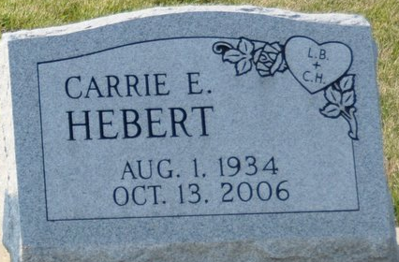
Photo by Deb Curry

Carrie E. Hebert, 72 years old of Cridersville, Ohio and formerly of Decatur, Indiana, passed away on Friday, October 13, 2006 in Roselawn Manor located in Spencerville, Ohio. She was born on Wednesday, August 1, 1934 in Decatur, Indiana the daughter of the late Dorwin Drake and the late Cora (Springer) Drake.
She was employed by Miller's Laundry in Wapakoneta, Ohio and she had previously worked at Signa Corporation, which is now Thunderbird Products of Decatur, Indiana.
Surviving are her daughter, Vickie (George) Brown of Tipp City, Ohio, daughter, Debbie King of Union Mills, Indiana, son, Earl (Vickie) Baker Jr. of Decatur, Indiana, daughter, Glela (Ben) Hower Jr. of Wapakoneta, Ohio, son, Robert Neale Jr. of Michigan City, Indiana, brother, Robert Drake of Decatur, Indiana, twelve grandchildren, 15 great-grandchildren, and 2 great great-grandchildren.
Preceding Carrie in death were one son, Dennis Eudon Hill, two sisters, six brothers and her life partner, Larady Brown.
Funeral services will be held at 11:00 a.m. Monday, October 16, 2006 in the Zwick & Jahn Funeral Home with Rev. Tom Ellis officiating. Interment will follow in the Decatur Cemetery. Friends will be received from noon to 2:00 p.m. and 4:00 p.m. to 6:00 p.m., Sunday, October 15 in the Zwick & Jahn Funeral Home, Decatur.
Preferred memorials are to donor's choice.

Zwick & Jahn Funeral Home, Adams County, Indiana
October 14, 2006

