Ada Louise (Wass) Hammond
February 3, 1937 – June 8, 2023

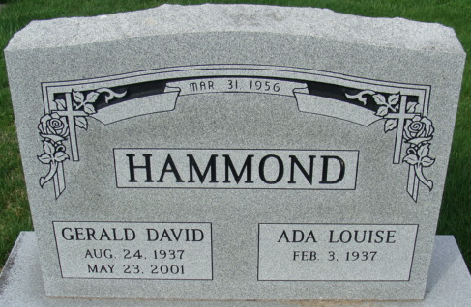
Photo by Alicia Kneuss

Ada “Louise” Hammond, 86, of Decatur, Indiana passed away Thursday, June 8, 2023 surrounded by her family at St. Anne Nursing Home in Fort Wayne, Indiana. She was born on February 3, 1937, in Adams County to the late Emmerson Wass and the late Valera (Hart) Wass. Louise was united in marriage to Gerald D. “Jerry” Hammond on March 31, 1956, and he preceded her in death on May 23, 2001.
Louise was a graduate of Decatur High School and attended the Warner Beauty School in 1955. She was a member of the East Liberty Church in Monroeville, Indiana.
She was a telephone operator for 20 years at the United Telephone Company. Jerry and Louise were owners of Hammond Produce in Decatur.
Louise enjoyed taking care of her yard, plants and taking care of the flowers at the Hammond Market and Garden Center. Louise was always willing to help others. Hard work was instilled into her on her parents’ dairy farm as a young girl. Louise enjoyed spending time with her grandkids whether it was going for a walk, playing video games, playing at the playground, or having a sleepover. She was blessed with 18 grandchildren, and she has a set of twins and triplets.
One song she always sang to each of her kids and grandchildren was Jesus Loves Me.
Survivors include her son, Rory R. (Samuel) Hammond of Humble, Texas; daughter, Ramona (Perry) Lehrman of Decatur, Indiana; son, Rex A. (Marlynn) Hammond of Aurora, Colorado; daughter, Renea J. (Randy Lehrman)Wells of Decatur, Indiana; daughter, Rhonda (Brian) Howk of Decatur, Indiana; daughter, Rachelle (Lisa) Hammond of New Haven, Indiana; four brothers, Dean (Cindy) Wass of Decatur, Indiana, Dale (Shirley) Wass of Decatur, Indiana, Duane (Kathy) Wass of Indianapolis, Indiana, and Steve Wass of Monroeville, Indiana; three sisters, Jean Ternet of Monroeville, Indiana, Jane Busick of Woodburn, Indiana, and Loretta (Jim) Waymire of The Villages, Florida; eighteen grandchildren: Chris and Landon Lehrman, Nicole Ayala, Jennifer Norman, Shaun Hirschy, Tara Wilson, Erika Hammond, Karey Selking, Alex Hammond, Cassandra and Cody Barkley, Cameron and Carson Howk, Burgandy and Bobby Jacklin, Madison, Mckinzie and Morgan Hammond; and 13 great-grandchildren.
She was preceded in death by a son, Robert Hammond; brothers, Roy and Dee Brian Wass, and sisters, Sheryl Wass and Shirley Frey.
A funeral service will be held at 10:30 a.m. Tuesday June 13, 2023 at East Liberty Church - 21215 Barkley Road, Monroeville, Indiana with Pastor Ralph Klinker officiating. Burial will follow in the Decatur Cemetery. Family and friends will be received on Monday, June 12, 2023 from 3-7 p.m. at the Zwick & Jahn Funeral Home in Decatur and one hour prior to the service on Tuesday at the church.
Preferred memorials can be given to East Liberty Church.

Zwick & Jahn Funeral Home, Adams County, Indiana
June 9, 2023

