Cascille L. “Cassie” (Reynolds) Haines
May 3, 1949 – March 31, 2025

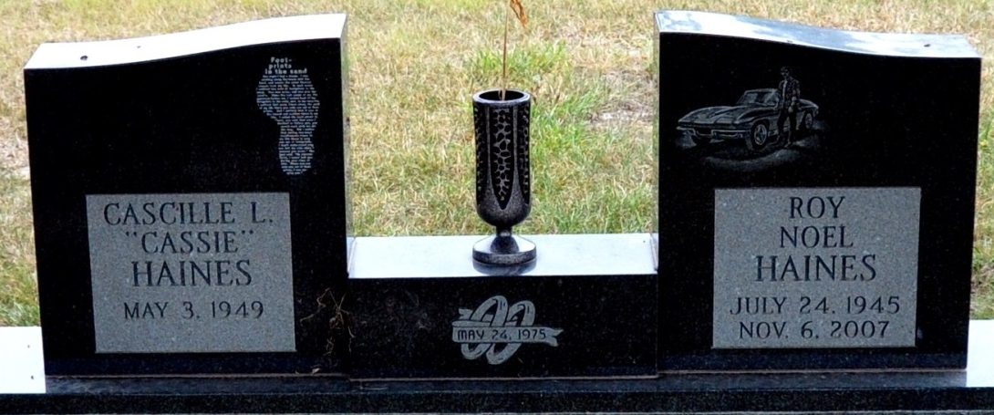
Photo by Deb Curry

Cassie “Cascille” L. Haines, 75, of Berne, passed away Monday afternoon, March 31, 2025, at Lutheran Hospital. She was born on May 3, 1949, in Decatur, IN, the daughter of Lloyd “Ed” and Bernadetta (Eley) Reynolds. Cassie was united in marriage to Roy Haines, he preceded her in death on November 6, 2007.
She attended the Bridge Community Church and retired from C.T.S.
Cassie enjoyed bowling, reading and crossword puzzles.
She is survived by her daughter, Amanda (Bart) Harris of Geneva, IN; her son, Chad Haines of Berne, IN; a sister, Lynette (Ray) Kirchner of Decatur, IN; 2 granddaughters, Jessica Sutton and Ashley Harris.
Cassie was preceded in death by her sister, Sue Meyers-Nearon.
A Funeral Service will be held at 2:00 p.m. on Saturday, April 5, 2025, at Haggard-Hirschy & Zelt Funeral Home, with visitation prior to the service from Noon – 2:00 p.m. Rocky Evans will be officiating and burial will follow in Decatur Cemetery.

Haggard & Sefton Funeral Home, Adams County, Indiana
April 1, 2025

