Simeon J. Hain II
March 26, 1922 – December 3, 2020

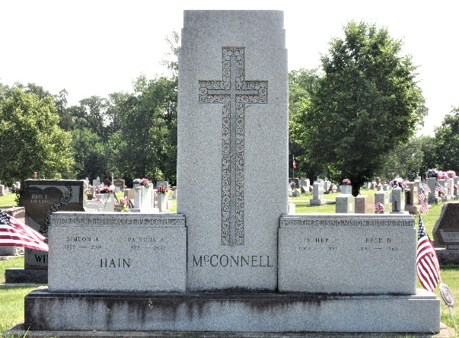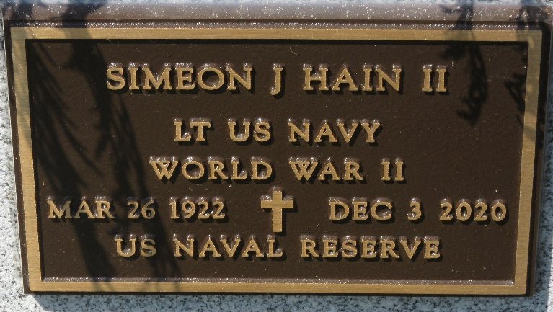
Photos by PLS

Simeon J. "Simmie" Hain II, 98, Decatur, passed away Thursday, Dec. 3, 2020, at Woodcrest Nursing Home. He was born in Decatur March 26, 1922, to the late Simeon J. and Anna M. (Bertel) Hain. On July 29, 1945, he married his childhood sweetheart, Patricia A. McConnell; after 66 years together, she preceded him in death March 28, 2012.
He was a lifelong parishioner of St. Mary of the Assumption Catholic Church. Simmie began working for his father's meat market in downtown Decatur, then went on to work for Central Sugar Company. In 1942, he enlisted in the United States Navy Reserve, a key component of the U.S. Navy, as an Aviation Cadet. Following months of training in multiple aircraft, he joined his fellow countrymen and allies in World War II. He was stationed in the Philippines and used his newfound skills and training to pilot the B24 patrol bomber. He ran more than 40 combat missions all over the South Pacific Theatre for three years. He then returned stateside and was honorably discharged in November of 1945. He attained the rank of Lieutenant and was most notably awarded the Distinguished Flying Cross twice, among many other decorations. Simmie cherished the time he gave for his beloved country and was proud to be a part of the Greatest Generation.
Upon returning to Decatur with his wife, he then managed real estate and properties for his father-in-law, Fred McConnell. In 1962, he went to work for Lincoln National Life Insurance of Fort Wayne, retiring after 30 years. He was a member of the American Legion Post 43.
Simmie and Patricia shared a love for traveling and made 27 trips abroad in 32 years. From the Great Wall of China to the Pyramids of Egypt, they truly loved exploring the world. They passed this love of adventure to their children and grandchildren.
Among survivors are a son, Simeon J. (Karen) Hain III of Zionsville; daughter, Pamela D. (Robert) Westfall of Valparaiso; four grandchildren and eight great-grandchildren; and companion, Pauline Shaffer of Decatur. He was preceded in death by four brothers and three sisters.
A Funeral Liturgy will be at 11 a.m. Saturday at Haggard-Sefton-Hirschy & Zelt Funeral Home, with visitation one hour prior to the service, from 10-11 a.m. Father Dave Ruppert will officiate and burial will follow in the Decatur Cemetery, with Military Graveside Rites conducted by the American Legion Post 43 Color Guard. Preferred memorials are to St. Joseph Catholic School.

Decatur Daily Democrat, Adams County, Indiana
Dec. 9 to Dec. 10, 2020

