Theresa (Spuller) Gillig
January 26, 1817 – October 26, 1894

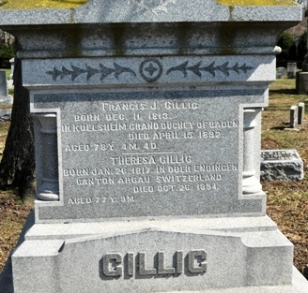
Photo by Deb Curry

Mrs. F. G. Gillig, mother of Amos Gillig and Mrs. Sylvester Spangler, who has been afflicted with a complication of diseases for a number of years, died last Friday evening, age 77 years, 9 months and 20 days.
Funeral services were held last Monday at the M. E. church, of our city, conducted by Rev. Gregg; interment in Maplewood Cemetery.

The Democratic Press, Adams County, Indiana
Thursday, November 1, 1894

**
Theresa Spuller from tree Roy Family Tree
Birth 26 Jan 1817 Switzerland
Marriage 1 Jan 1838 Huron, Erie, Ohio, USA
Residence 1880 Decatur, Adams, Indiana, USA
Death 28 Oct 1891 Decatur, Adams, Indiana, USA
Father George Spuller (1781-1871)
Mother Mary Keller (1784-1825)
Spouse Francis Joseph Gillig (1813-1892)
70261 People 9 Records 19 Sources
Note: 5 other trees have the 1891 death date

