Glen H. Geyer
December 8, 1931 – November 7, 2023

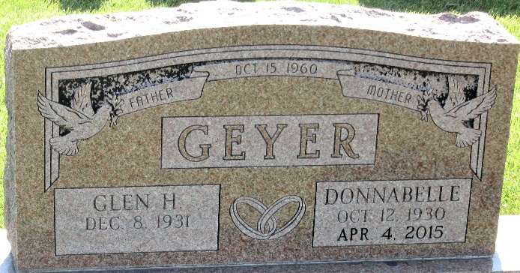
Photo by PLS

Glen H. Geyer, 91, of Decatur, passed away Tuesday, November 7, 2023, at Adams Woodcrest. He was born on December 8, 1931, in Adams County, the son of the late Eli and Lydia (Steffen) Geyer. On October 15, 1960, he married Donnabell Hurst Affolder, she preceded him in death on April 4, 2015.
Glen worked at B.F. Goodrich in the processing department and after retirement, he did maintenance work at Adams Memorial Hospital. Glen also served in the United States Army.
He is survived by his son, Don “Butch” (Marcia) Affolder of Decatur; his daughter, Linda (John) Lose of Decatur; his sister, Dorothy “Dot” Vanhorn of Decatur; 7 grandchildren; 12 great grandchildren; 3 great-great grandsons; numerous nieces and nephews.
Glen was preceded in death by his 6 brothers, Loyal, Donald, Earl, Lester, Verlyn and George Geyer; 3 sisters, Lavera Heyerly, Ilean Steffen and Berthelean Reinhard; a nephew, Jesse Hurst.
A Funeral Service will be held at 11:00 a.m. on Saturday, November 11, 2023, at Haggard-Hirschy & Zelt Funeral Home, with visitation an hour prior from 10:00 – 11:00 a.m. The service will be officiated by Gene Hurst. Burial will take place in Decatur Cemetery.
In Lieu of Flowers, contributions may be given to Honor Flight or Heart to Heart Hospice.

Haggard & Sefton Funeral Home, Adams County, Indiana
November 8, 2023

