Donnabelle (Hurst) Geyer
October 12, 1930 – April 4, 2015

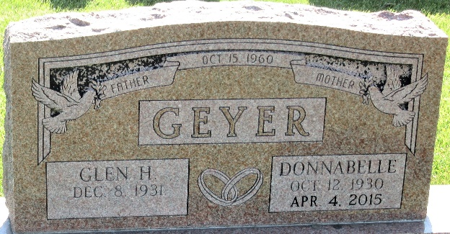
Photo by PLS

Donnabell (Hurst) Geyer, 84, of Decatur, IN, died at her residence on Saturday, April 4, 2015. Donnabell was born in Adams County, IN on October 12, 1930 to the late Arthur and Anna (Burkhead) Hurst. On October 15, 1960 she married Glen Geyer.
Donnabell was a member of Grace Fellowship. She worked at G.E. and Decatur Casting.
She is survived by her husband of 54 years, Glen Geyer of Decatur; a son Don “Butch” (Marcia) Affolder and a daughter Linda (John) Lose both of Decatur; and nephew, Jesse Hurst; 4 brothers, Richard (Ruth) Hurst, Ronald “Mike” Hurst, Jerry (Carmen) Hurst, Carl Eugene (Shirley) Hurst; 7 grandchildren and 11 great grandchildren. She was preceded in death by her first husband, Donald J. Affolder, 2 brothers, Arthur Hurst Jr. and Bob Hurst and a sister Barbara Geyer.
Visitation will be from 4:00 – 7:00 p.m. on Wednesday, April 8, 2015 at Haggard-Sefton & Hirschy Funeral Home. Funeral Service will be held at 10:30 a.m. on Thursday, April 9, 2015 at Haggard-Sefton & Hirschy Funeral Home. Officiating will be Pastor Dan York and burial will take place in the Decatur Cemetery.
Memorials may be made to ACCF Alzheimer’s/Dementia Fund, Grace Fellowship, or Family Life Care.

Haggard & Sefton Funeral Home, Adams County, Indiana
April 5, 2015

