Vicky K. (Painter) Garrett
February 9, 1949 – August 6, 2003

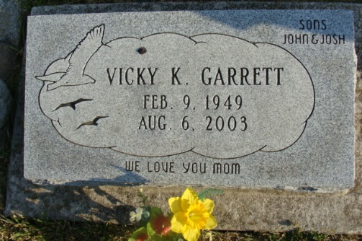
Photo by Alicia Kneuss
VICKY K. GARRETT, 54, of Decatur, died Wednesday, Aug. 6, 2003. Arrangements by Haggard & Sefton Funeral Home, 225 W. Adams St., Decatur.

Journal Gazette, The (Allen County, Indiana)

August 8, 2003

**

Indiana, Death Certificates, 1899-2011
Name: Vicky K Garrett
[Vicky K Painter]
Gender: Female
Race: White
Age: 54
Marital status: Divorced
Birth Date: 9 Feb 1949
Birth Place: Ft Wayne, Indiana
Death Date: 6 Aug 2003
Death Place: Fort Wayne, Allen, Indiana, USA
Father: Donald A Painter
Mother: Evelyn P Klemz
Informant: Mr. John Shank; son; Decatur, Ind.
Cremation: Aug. 8, 2003; Northern Indiana Crematory Corp., Fort Wayne, Ind.

