Chauncey Furman
March 16, 1855 – February 3, 1923

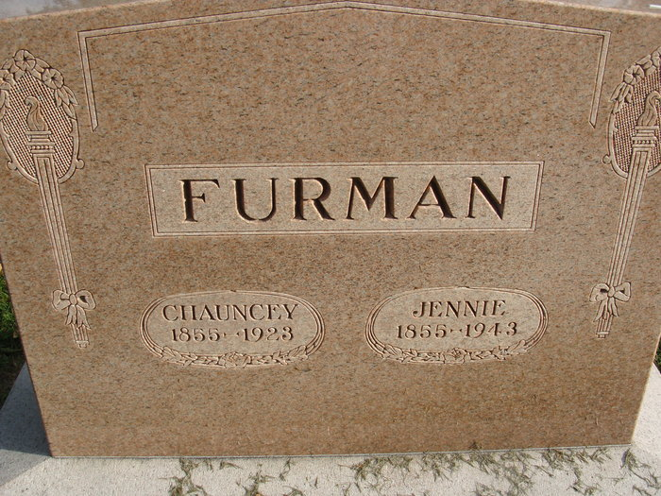
Photo by Alicia Kneuss

C. J. FURMAN DIED TODAY
Word was received here today that Chauncey J. Furman, age 67 years died at his home in Marion, Ohio, at 7:25 o’clock this morning, following a stroke of paralysis which he suffered a week ago yesterday.
The body will be brought to this city for burial and will arrive at 12:54 o’clock Monday afternoon.
Mr. Furman was well known here having visited here frequently. Mrs. Furman formerly was Mrs. Jennie Studebaker.
Decatur Daily Democrat, Adams County, Indiana
Saturday, February 3, 1923

**
FURMAN BODY BURIED HERE
Masons Hold Ritualistic Services at Grave Of Chauncey J. Furman
The body of the late Chauncey J. Furman, of Marion, Ohio, was brought to Decatur this afternoon and buried in the Decatur Cemetery. Mr. Furman died in Marion last Saturday morning. The body was met at the Erie train due into Decatur at 12:54 p.m. by the Decatur Lodge of Masons and by the Shakespeare Club and escorted to the cemetery where ritualistic services were held by the Masons.
Following is an account of Mr. Furman’s death and his obituary, which appeared in the Marion Sunday Tribune: “Chauncey J. Furman, aged nearly 68 years, died Saturday morning at 7:20 o’clock at his home, 251 Summit Street as the result of the stroke of apoplexy sustained Thursday morning, January 25. Though conscious most of the time, Mr. Furman was helpless and could not speak a word. He failed gradually until the end, passing away with a nurse at his bedside.”
Mr. Furman was born at Vassar, Mich., March 16, 1855. For a number of years Mr. and Mrs. Furman have passed several weeks at Hot Springs, Arkansas, the time extending over his birthday date, and they had made all preparations to go again, having their trunks packed to leave Sunday. Mr. Furman’s early life was passed at Vassar, but for forty-three years, he had been a conductor on the Erie Railroad, running between Marion and Chicago. He was married at Vassar, and this wife preceded him in death many years ago. Walter Furman of Vassar, a son by the marriage, survives. There are also two grandchildren. On December 22, 1905, Mr. Furman was married at Decatur, Indiana, to the wife who survives, and they have lived in Marion since that time. Besides the son, wo is enroute to Marion, one sister, Mrs. Couch, of Minneapolis, Minn., and a cousin, Mrs. T. B. Kenyon, of Lincoln, Neb., are left. The latter is also on her way here, and the sister may come if word can reach her in time.
Mr. Furman was a member of the Order of Railway Conductors, having joined at Huntington, Indiana, and was very popular with the railway people-officials and fellow employees. He also held membership in the Elks Lodge of Huntington and in Masonic Orders here-Marion Lidge No. 70, F. & A.M., Marion Chapter No. 62, R. A. Marion Council No. 22 R. & S.M., and Marion Commandery No. 36, Knights Templar. He was generous with his charities, though what he did was unknown to his closest relatives and friends.
Funeral services will be held Sunday evening at seven o’clock at home, in charge of Marion Commandery, Dr. Jesse Swank officiating. Monday morning the body will be taken to Decatur, Ind., on No. 3 Erie, for burial, and the masonic Lodge of Decatur will have charge of services at the cemetery.”
Decatur Daily Democrat, Adams County, Indiana
Monday, February 5, 1923

