Marilyn C. (Mauller) Fruchte
July 21, 1934 - April 26, 2025

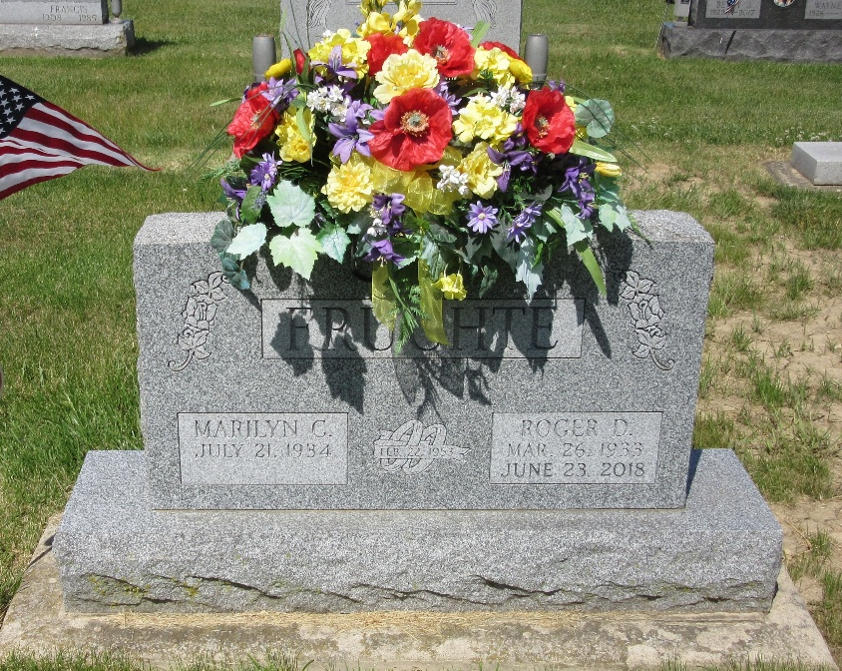
Photo by PLS

Marilyn C. Fruchte, 90, of Decatur, Indiana, passed away on Saturday, April 26, 2025 at Adams Woodcrest. She was born on July 21, 1934 in Decatur, Indiana to the late Glenn Mauller and Dorothy M. (Fawcett) Mauller. Marilyn was united in marriage to the late Roger D. Fruchte on February 22, 1953 at First Evangelical Church in Decatur, Indiana. Roger preceded her in death on June 23, 2018.
She was a member of Zion United Church of Christ in Decatur, Indiana. She was a 1952 graduate of Decatur High School. She was employed with Adams County Courthouse for over 20 years and retired from the City Clerks office. Marilyn enjoyed sewing, gardening, playing cards, participating in the Red Hat Society. She enjoyed spending time with family, especially her grandchildren.
She is survived by her son, Michael (Linda) Fruchte of Decatur, Indiana; son, Mark (Lynn) Fruchte of Decatur, Indiana; son, David (Ann) Fruchte of Carthage, North Carolina; daughter, Michelle (John) Hess of Decatur, Indiana; sister, Becky (Bob) Ladd of Decatur, Indiana; 11 grandchildren, Lori Ruble, Jonathan ( Megan ) Fruchte, Carrie (Jason) Walters, Lyndsey (Sam) Fennig, Nicole (Nick) Ruble, Sara (Ryan) Rumschlag, Ryan (Jenny) Fruchte, Jordan Fruchte, Megan (Daniel) Liederbach, Andrew (Kaylie) Hess and Andrea (Lance) Shifferly; 24 great-grandchildren, Anna, Luke, Sam, Grace, Ellie, Amelia, Clara, Alexis, William, Rhett, Gabe, Josie, Ben, Charlotte, Harrison, Hallie, Adi, Trey, Reagan, Jaxon, Brody, Emmie, Emma, and Russell and several nieces and nephews.
Along with her parents and spouse, she was preceded in death by grandson-in-law, Paul Ruble.
Funeral services for Marilyn will be held at 2:30 p.m. on Wednesday, April 30, 2025 at the Woodcrest Porter Auditorium with Pastor Allen Kahler officiating. A burial service will follow at Decatur Cemetery. Family and friends will be received from 12:30 p.m. until service time on Wednesday at the Woodcrest Porter Auditorium.
In lieu of flowers and gifts the family requests that memorials be to Zion United Church of Christ or A.C.C.F-Paul Ruble Scholarship.

Zwick & Jahn Funeral Homes, Adams County, Indiana
May 2, 2025

