Diane M. (Coyne) Friedt
September 8, 1962 – July 3, 2023

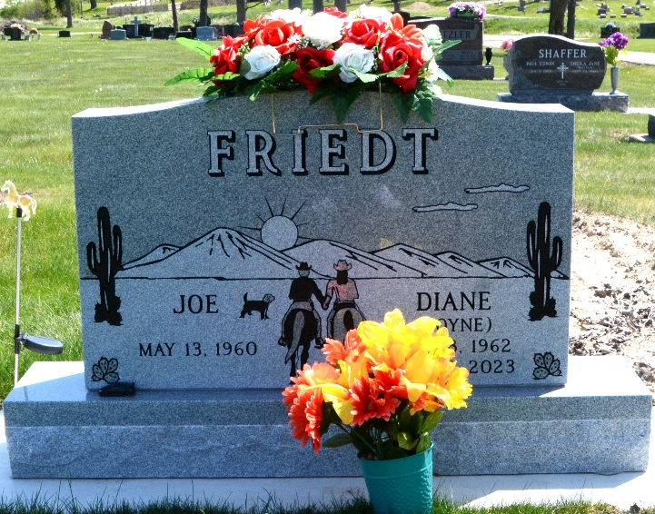
Photo by Barbara Baker Anderson

Diane M. (Dee) Friedt, 60, of Decatur, passed away July 3, 2023, way too young, peacefully at home with family by her side. Dee married her high school sweetheart Joe Friedt on April 16, 1983, with 40 years of love and laughter.
Dee was always known for her kind heart and positivity. She loved being a mother and grandmother most of all. She had a love for horses since before she could walk. She would come to raise, train and barrel race with her daughter Callie. Many weekends were spent traveling and competing. The horse barn was where she loved to relax happily doing chores. On other days, her love was spent cheering on her son, Jared, succeeding in almost every sport going on at that time. In later years it was her grandson, Theo, and her dog Zippy which was her joy!
Dee is survived by her children, Jared (Megan) Friedt, grandson Theo Friedt, and Callie (Bryce) Kukelhan; 2 brothers, Greg Coyne, and Chris (Amy) Coyne all of Decatur and 2 sisters, Carol (Kevin) Geyer of Ft. Wayne and Barbara Mullen of South Whitley.
She was preceded in death by her parents, Eugene and Marcile (Bentz) Coyne.
Private family services were held, followed by burial in Decatur Cemetery.
Haggard & Sefton Funeral Home, Adams County, Indiana
July 10, 2023

