Linn A. (McBride) Fore
August 31, 1956 – August 8, 2021

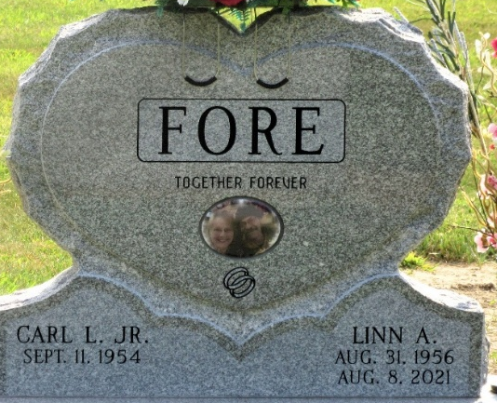
Photo by PLS

Linn A. Fore, 64, of Decatur, Indiana passed away late Sunday evening, August 8, 2021, at her residence. She was born on August 31, 1956 in Decatur, Indiana to Floyd I. McBride and Sandra L. (Fisher) McBride Hein. Linn married Carl L. Fore, Jr. on October 23, 1974 at First United Methodist Church in Decatur.
She attended the First United Methodist Church in Decatur. Linn was employed by Deans Foods (DFA) in Decatur for 22 years where she was the lead filler operator of the ice cream sandwich line.
She loved singing, crocheting, hiking, bicycling, canoeing, and camping. She also loved to play trivia and board games. Linn loved her grandkids to pieces.
Survivors include her husband, Carl Fore of Decatur; two daughters, Misty (Craig) Jones and Cristy (Thomas Barnett) Scott both of Decatur; two grandsons, Canen (Elizabeth Bonjour) Keys and Benjamin Barnett both of Decatur; granddaughter, Carley (Justin Shaffer) Gambill of Lake Geneva, Wisconsin; great-grandson, Sterling Keys; step-mother, Rochelle McBride of Decatur; brother, Brad McBride of Decatur; step-brother, Robert (Terri) Hein of Germany; three sisters, Dawn (Jack) Crandal of Churubusco, Indiana, Mona (Joe) Smith and Jody (Donald) Wietfeldt both of Decatur; step-brother, Jeff (Lisa) Smitley of Vandallia, Michigan; two step-sisters, Lanae (John) Abnet of Berne, Indiana and Cassandra (Blair) Ballard of Lakeland, Florida; and best friend, Claudine Russell of Decatur. She is also survived by many nieces and nephews.
Linn was preceded in death by her son-in-law, Lyle Scott and two nephews, Randy Weiland and Daniel McBride.
A funeral service will be held at 10:30 a.m. Friday, August 13, 2021, at Zwick & Jahn Funeral Home in Decatur with Pastor Harold Klinker officiating. Burial will follow at Decatur Cemetery. Family and friends will be received from 2 to 5 and 6 to 8 p.m. Thursday, August 12, 2021 at the Zwick & Jahn Funeral Home in Decatur and one hour prior to the funeral on Friday at the funeral home.
Preferred memorials are to Adams County Community Foundation-Cancer Fund.

Zwick & Jahn Funeral Home, Adams County, Indiana
August 9, 2021

