Allen Lee Fleming
May 17, 1933 – August 25, 2023

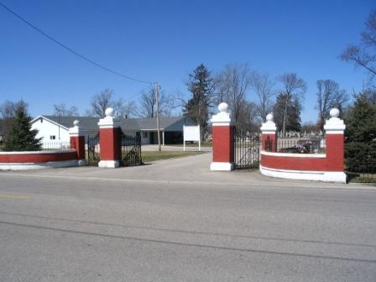
Barbara Baker Anderson

Allen Lee “Al” Fleming, 90, lifelong Decatur resident, who wintered in Florida passed away Friday, August 25, 2023, at Stillwater Hospice Home in Fort Wayne, Indiana. He was born on May 17, 1933, in Decatur, Indiana to the late Lee K. and Dora (Doehrman) Fleming.
Al was a member of Zion Lutheran Church in Decatur.
Additionally, he was a member of the American Legion Post #43 and the Elks Lodge #993 both in Decatur. Al was President and Founder of Fleming Excavating / Al Fleming Inc. for 38 years retiring in 1993. He also was the founder of the Adams County Sand and Gravel Inc. and founder of Fleming Properties, Inc. He was an honorably discharged member of the United States Army during the Korean War.
Al went to Monmouth School where he quit his junior year. His teacher told him that he was going to dig ditches the rest of his life. That teacher was absolutely correct, only she thought he would be digging them by hand and not equipment. Al loved operating anything powered, be it construction equipment, planes, or boats. Al enjoyed boating whenever possible in the Great Lakes and in Florida. He was especially proud to have completed the journey from the Great Lakes to Florida via the Mississippi River and also via the East Coast. He continued operating equipment until just a few years ago but would still visit jobsites via his Polaris ATV. One of his greatest qualities was being able to go up to a complete stranger and carry on a conversation and making them feel like his friend.
He is survived by his Son, Gregory (Barb) Fleming of Decatur, Indiana; daughter, Nancy (Derold) Covell of Fremont, Indiana; daughter, Candace (Barry) Williamson of Decatur, Indiana; friend and Companion, Carol Bailey of Decatur, Indiana; brother, James A. (Carol) Fleming of Parrish, Florida; sister, Kathleen R. (Pete) Bergdall of Decatur, Indiana; six grandchildren, Kelsey (Troy) Tiernon, Sherice (Carlin) Hormann, Keegan (Jena) Covell, Lance Williamson, Brian (Amy) Williamson, and Sara (Paul) Mesing; and seven great-grandchildren, Callahan Hormann, Oliver Hormann, Blakely Covell, Beckett Covell, Brynnley Covell, Oakley Mesing, and Kenzie Mesing.
A funeral service will be held at 11:00 a.m. Thursday, August 31, 2023, at Zion Lutheran Church, Decatur with Pastor Zachary Oedewaldt officiating. Burial will take place at a later date at Decatur Cemetery. Friends and family will be received from 2-5 p.m. and 6-8 p.m. on Wednesday, August 30, 2023, at the Zwick & Jahn Funeral Home in Decatur and from 9:30 a.m. to 10:45 a.m. prior to services at the church on Thursday, August 31, 2023. Military honors will be conducted by the American Legion Post #43 following the funeral service at church on Thursday.
In lieu of flowers the family asks that preferred memorials be given to Zion Lutheran Church; Adams County Community Foundation –Allen Fleming Family Fund; or Stillwater Hospice.

Zwick & Jahn Funeral Home, Adams County, Indiana
August 29, 2023

