Wava A. (Fox) Fiechter
April 19, 1933 – January 8, 2021

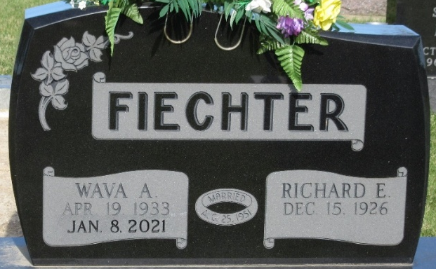
Photo by PLS

Wava A. Fiechter, 87, of Craigville, IN, passed away at her residence on Friday, January 8, 2021. She was born in Adams County on April 19, 1933, the daughter of the late Jesse and Dora A. (Hirschy) Fox. On August 25, 1951, Wava married Richard E. Fiechter.
She was a member of Hope Missionary Church in Bluffton and the Agape Sunday School Class. She also was involved in a Bible Study in Decatur and was a member of the Purdue Extension Homemakers Club.
Wava worked as a homemaker and helped her husband run the farm. She also worked as secretary for Caylor-Nickel for 2 years and Businessmen’s Insurance for 3 years. She enjoyed traveling and taking bus trips with her husband.
She is survived by her husband of 69 years, Richard E. Fiecther of Craigville; daughter, Angela (Christopher) Gahman of Uniondale; sister, Norma Shelton of Decatur; 2 sisters-in-law, Barb Fox and Mary Jo Fox both of Decatur; 2 granddaughters, Nicole and Stephanie Gahman; a great grandson, Jonathan Gahman. She was preceded in death by 2 brothers, Leonard and Ferris Fox.
Visitation will be on Tuesday, January 12, 2021 from 4:30 – 6:30 p.m. at Haggard-Sefton-Hirschy & Zelt Funeral Home, Decatur.
A Funeral Service will be held at 2:00 p.m. on Wednesday, January 13, 2021 also at the funeral home, with calling 1 hour prior from 1:00 – 2:00 p.m. Pastor Gary Aupperle will be officiating. Burial will follow in Decatur Cemetery.
Memorials may be given to Hope Missionary Church.

Haggard & Sefton Funeral Home, Adams County, Indiana
January 8, 2021

