Marlene M. (Ohler) Fast
January 25, 1937 – January 18, 2024

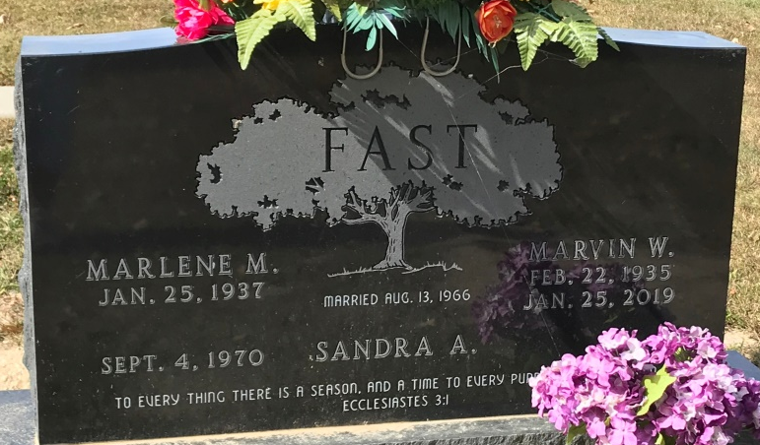
Photo by PLS

Marlene M. Fast, 86, of Ohio City, Ohio, passed away on Thursday, January 18, 2024, at Adams Memorial Hospital. She was born on January 25, 1937, in Decatur, Indiana to the late Kenneth Ohler and the late Ruth (Holle) Ohler. Marlene was united in marriage to Marvin W. Fast on August 13, 1966, at Zion Lutheran Church in Decatur and he preceded her in death on January 25, 2019.
She was a member of Zion Lutheran Church in Decatur.
Marlene was employed by General Electric in Decatur until 1969.
She loved caring for her cats and dogs and enjoyed feeding the birds. Marlene loved going to garage sales and auctions with her daughter. Marlene was an avid reader and enjoyed doing yard work.
Survivors include her daughter, Sandra Fast of Ohio City, Ohio; brother, Melvin Ohler of Decatur, Indiana; Marvin’s family; two sisters Dorothy Brown of Ohio City, Ohio, and Connie (Larry) Weaver of Decatur, Indiana; brother, Melvin Fast of Decatur, Indiana; and brother-in-law, Lee Wolfe of Pleasant Mills, Indiana.
In addition to her parents and husband, she was preceded in death by two sisters, Marie Hegemier, and Mary (Al) Schnitz: and Marvin’s family, two sisters, Donna Wolfe and Carolyn (Bill) McCullough; brother-in-law, Pete Brown; and sister-in-law, Colleen Fast.
A funeral service will be held at 10:30 a.m. on Thursday, January 25, 2024, at the Zwick & Jahn Funeral Home, Decatur with Pastor Zachary Oedewaldt officiating. Burial will follow in the Decatur Cemetery.
Family and friends will be received from 3-5 and 6-8 p.m. Wednesday, January 24, 2024, at the Zwick & Jahn Funeral Home, Decatur and one hour prior to the service on Thursday at the funeral home.
Preferred memorials can be given to Zion Lutheran Church, Decatur.

Zwick & Jahn Funeral Home, Adams County, Indiana
January 19, 2024

